

**Online Booking System**

**Omed Hassan Ahmed**

**Student No: 110565435**

**MSc. Software engineering**

**Date: 22/08/2013**

[Word Count: 19.305]

Abstract

This project aims to develop an Online Booking System for hotels where users are able to search for cheapest hotel and book in advance, as well as find the tourist attraction places and restaurants nearby each hotel.

Acknowledgments

First I would like to express my deepest appreciation to my project dissertation supervisor Dr Marta Koutny for her guidance and suggestion, who’s helped me to coordinate my project dissertation specially in writing this report. I would also thank Dr Viktor Khomenko for the creation and revisions of “MSc Projects and Technical Writing” document which was a great help to me to complete this project. Finally I would like to thank my family and friends, who have supported me throughout entire process.

Table of Contents

1 Introduction 8

1.1 Description of the proposed project and its context 8

1.2 Aims and Objectives: 9

1.3 Outline of dissertation 9

2 Background of the Study 10

2.1 Tourism Industry and Hotel Booking System 10

2.2 Role of Hotel booking process in the tourism industry 11

2.3 Pros & Cons of hotel booking systems around the world 11

2.4 Usability heuristics 15

2.4.1 Visibility 15

2.4.2 Match between the system and the real world 15

2.4.3 User control and freedom 15

2.4.4 Consistency and standards 15

2.4.5 Error prevention 15

2.4.6 Recognition rather than recall 15

2.4.7 Aesthetic and minimalist design 16

2.4.8 Help users recognise and recover from errors 16

2.4.9 Help and documentation 16

2.5 Example of Existing Hotel Booking System 16

2.5.1 System 1-https://www.holidayinn.com 16

2.5.2 System 2-https://www.travelrepublic.co.uk 19

2.5.1 21

2.5.2 21

2.6 Key Technologies 22

2.6.1 PHP (**H**ypertext **P**re-processor): 22

2.6.2 MySQL: 22

2.6.3 XHTML and XML: 22

2.6.4 CSS (**C**ascading **S**tyle **S**heet): 23

2.6.5 Java Script: 23

2.7 Software Development Methods 23

2.7.1 Waterfall model 23

2.7.2 Agile Model 23

2.7.3 Prototype Model 23

2.8 Dijkstra’s Algorithm 24

3 Requirement analyse: 26

3.1 List of Requirements 26

3.1.1 Make reservation in advance 26

3.1.2 Create an account before make reservation 26

3.1.3 User cancel reservation 26

3.1.4 User view reservation 26

3.1.5 Modify user personal detail 26

3.1.6 User sign up for email offers 26

3.1.7 Password recovery 26

3.1.8 Change password 26

3.1.9 Receive confirmation email on every successful booking 26

3.1.10 Provide information about tourist attraction places, restaurants and etc... 26

3.1.11 User ability to contact administrator 26

3.1.12 View and delete reservations by administrator 26

3.1.13 View, edit and delete rooms by administrator 26

3.1.14 View and delete room amenities by administrator 26

3.1.15 Read and delete user comments by administrator 26

3.1.16 User print reservation detail 26

3.1.17 Usability (Simple GUI and user friendly) 26

3.1.18 Performance (how quickly system reacts to user input) 26

3.1.19 Reliability (ability of the system to perform multiple functions) 26

3.1.20 Maintainability (Easy to fix when brake down occurred) 26

3.1.21 Availability (System is available to everyone at all the time) 26

3.1.22 Accessibility (System is accessible to those users who are handicapped in some way) 26

3.1.23 Security (Secure logging system). 26

3.2 Functional Requirements 27

3.3 Non-Functional Requirements 27

4 Design 28

4.1 Database 28

4.1.1 Overview 28

4.1.2 Data Dictionary 28

4.1.3 Table normalisation 32

4.1.4 Database background 32

4.1.5 Entity Relationship Diagram (ERD) 33

4.1.6 Platform selection 34

4.1.7 Query optimisation 34

4.2 Website 34

4.2.1 Discussion 34

4.2.2 Navigation chart 37

4.3 Initial requirements analysis of user interaction 38

4.3.1 Initial ideas for a GUI 38

4.3.2 Use cases 45

4.3.3 Activity diagrams 46

5 Implementation 52

5.1 Login 52

5.2 Customer login area 52

5.3 Admin login area 52

5.4 Sessions 53

5.5 Available rooms 53

5.6 Send data to database 53

5.7 Retrieve data from database 54

5.8 Booking ref number 54

5.9 Send confirmation email 55

5.10 Change password 55

5.11 Forgot password 56

5.12 Data manipulations (Add, edit and delete) 56

5.12.1 Add rooms 56

5.12.2 Edit type of room 57

5.12.3 Delete room 57

5.13 Dijkstra algorithm 57

5.13.1 Start to destination 58

5.13.2 Start to destination (Via) 58

5.13.3 Start to destination (Avoid) 59

6 Testing 62

6.1 Web standard validation 62

6.1.1 HTML validation 62

6.1.2 CSS validation 63

6.2 Web browser compatibility 63

6.2.1 Firefox 63

6.2.2 Google Chrome 64

6.2.3 Internet Explorer 64

6.2.4 System testing 65

7 Evaluation 67

7.1 Requirements 67

7.1.1 Make reservation in advance 67

7.1.2 Create an account before make reservation 68

7.1.3 User cancel reservation 68

7.1.4 User view reservation 69

7.1.5 Modify user personal detail 69

7.1.6 Password recovery 69

7.1.7 Change password 70

7.1.8 Receive confirmation email on every successful booking 70

7.1.9 Provide information about tourist attraction places, restaurants and etc... 71

7.1.10 User ability to contact administrator 71

7.1.11 View and delete reservations by administrator 71

7.1.12 View, edit and delete rooms by administrator 72

7.1.13 Read and delete user comments by administrator 73

7.1.14 User print reservation detail 73

7.1.15 Usability 73

7.1.16 Performance 73

7.1.17 Reliability 74

7.1.18 Maintainability 74

7.1.19 Availability 74

7.1.20 Accessibility 74

7.1.21 Security 75

7.2 Apply usability heuristics 75

7.2.1 Visibility 75

7.2.2 Match between the system and real world 75

7.2.3 User control and freedom 76

7.2.4 Consistency and standards 76

7.2.5 Error prevention 76

7.2.6 Recognition rather than recall 76

7.2.7 Aesthetic and minimalist design 76

7.2.8 Help users recognise and recover from errors 77

7.2.9 Help and Documentation 77

8 Conclusion 77

8.1 Meeting Objectives 78

8.2 Positive and negative aspects 79

8.3 Reflective Learning 80

8.4 Scope of future research 80

9 References 81

# Introduction

## Description of the proposed project and its context

A hotel is an important establishment where the people can stay in for a period of time on payment basis. Previously the accommodation comprised of a room with basic features like table, cupboard etc. while today this has evolved and rooms comprise of different features like air-conditioning etc.

The cost indicates the quality of hotels and the different kind of services which are available. With the advancement of tourism in last few decades there have been many small hotels which have come up. These small hotels find it difficult to promote them and use the World Wide Web as a medium to promote themselves.

Most of the Hotels today offer good services using the web i.e. online booking system and websites. This helps ~~in~~ doing the tasks in a much simple and timely way. Most of the hotels have gone fully automated in terms of booking of rooms etc.

The software developers have developed computer systems which are simple to use and manage complex applications like booking of rooms, maintenance of room status, financial reporting, financial analysis etc. These programs are simple to operate and the users are provided with user manuals to operate.

With the advancement of new technology, the applications which are developed provide free interaction among users (Armstrong ,2004). The speed at which the operations are carried out in the automated system is more efficient than the manual system. In the hotel industry, many processes have been automated to increase the efficiency and accuracy. A transaction processing system called “Hotel Reservation System” is used in many hotels as the system has many advantages in comparison to manual Hotel Reservation.

The main aim of this project is to develop a hotel reservation system with user satisfaction and efficiency in mind. It is well known that the development of computer applications in the increase in services and user satisfaction, in the many sectors where they are used and the tourism industry is no exception. Continuous technological advances allow to develop better and more user friendly solutions.

In a manual reservation system, the vital role was played by the personnel of the hotel who looked after the booking process, and online system will be easer use and more accessible for users and hotel staff would save valuable time.

## Aims and Objectives:

* This project aims to develop an online booking system for hotels.
* Users are able to search for the cheapest hotels.
* Account area is provided where users are capable to have their own profile so that they can change and cancel booking or modify their details. In addition, once a purchase was made or a customer left the hotel, the system will automatically update the availability of services without human interaction.
* Admin area is provided where the administrator can view users booking details and add/edit or delete rooms or hotel.
* Tourist attraction places and restaurants and fastest routes leading to them, distance and time taken can be found through the system by using Dijkstra algorithm.

## Outline of dissertation

Chapter 1 discusses the introduction and system overview of the study. This section deals with the following statement of the problem according to the study, aims and objectives of the study. Chapter 2 deals with the background study related to the project, it is focuses on the feasibility studies discuss which includes technical feasibility and operational feasibility. Economic feasibility deals with the hardware and software depreciation cost. The cost will implement in the market analysis. Usability heuristics and example of existing systems. The technologies used to develop the system as well as software development methods. The chapter 3 focuses on requirement analyses with division for functional and non-functional requirement. The chapter 4 focuses on system design. The chapter 5 focuses implementation. . The chapter 6 focuses on testing methods. The chapter 7 focuses on the evaluation to satisfy specified requirements of the user to use the proposed system. The chapter 8 discusses the summary of the whole study. This section deals with conclusion and recommendation for the proposed system.

# Background of the Study

## Tourism Industry and Hotel Booking System

In today’s era of computers every business area has been affected by the efficiency of manual system. In the hotel industry also, the reservation system due to manual intervention has been considered as scope of improvement. Idea of introducing technology in the reservation system presents a scope of improvement. Emerging the internet has revolutionized the way people interconnect one another. Internet supports adopting Online booking systems that automatically and efficiently manage users’ affairs. Travellers no longer need to be present in the destination location for booking purpose; rather they can view available offers online, find suitable ones and book it in advance. Online booking systems provide many advantages which mainly find themselves in time-saving, cost-saving and convenience as well. For example a survey conducted by CBT Travel states that the main intention of 97 percent of the respondents was decreasing the total travel cost. Furthermore, it is believed that companies need to employ online booking system in order to achieve this cost reduction (Snyder, 2008).

The study presents the advantages of using a hotel reservation system over a manual reservation system and how a hotel reservation system can be implemented. The individual stimulation and interaction has been associated with the availability of the technology. With the advancement in information technology the manual transaction have gave their way to computerized transactions.

The most important issue which a hotel faces is the maintenance of the hotel databases. The Hotels find it difficult to find the vacant rooms, booking etc (Curtis ,2002). Thus a reservation system is being developed which will help in maintaining the details and records of the customers.

A transaction processing system for the use of hotels in solving problems related to manual hotel reservation has been developed and is coined the term Hotel Reservation System. The Hotel Reservation System automates the reservation process of the hotel and is more accurate and faster than the manual hotel reservation. The Database is shared over the network through the LAN (Local Area Network). Different techniques and tools are available for building the Hotel Reservation system (Daniel ,2004). The system must have a proper Graphical User Interface which must be clear and understandable for the users to carry out the transactions. The implementation of Hotel Reservation system helps in solving problems which are faced in the manual reservation process.

## Role of Hotel booking process in the tourism industry

Though a very old one in profession, but developments are a continuous process in this industry too. Peoples earlier were not very much aware of these things but as the days have changed and media and internet have uplifted the benefits of these things to the peoples gradually.

Being an industry, tourism nowadays is not restricted to the retail one as it was on the earlier. Lot and lot of developments have taken place which has broadened the scope of this sector. Besides retail tourism the traditional one, corporate sectors have taken into account the benefits of it. Few of such new concepts are eco tourism, leisure tourism, health tourism and more. A niche industry has also been developed from these concepts are times share industry(Daniel, 2004).. Corporate sectors have felt the benefits of it and are using it as key tools for motivations of their employees and or to taken care of the stress levels of their renowned employees. So the scenario have changed a lot from earlier and the companies who have engaged themselves in this services are very much concerned about the services being rendered by them to their most valuable clients and thus developed the concepts of earlier hotel booking. It is the key factor of tourism sector to provide better lodging in a reasonable price. So to provide the better services, advance booking came into the scenario. Earlier, in the eighties hotels were also not concerned about the advance booking, or online booking but nowadays they are giving prime importance in the advance hotel booking. They have identified the key benefits of advance booking that is they can estimate or even got the cash in hand partly or fully for a particular financial year in the starting of that financial year (Daniel ,2004). This gives the hotels a big chunk of money to reinvest into the business or any other further developments. The hotels have identified the reservation system as an area where they consider as scope of improvement. The automated reservation system will help in offering better services to the customer; this will help the hotels in improving their market value in terms of customer satisfaction and retaining the customer.

In the year 2020, as per an economic report it would the hotel industry is expected to grow by more than 40 percent, thus the hotels require a solution which should be reliable and efficient.

## Pros & Cons of hotel booking systems around the world

The hotel booking system follows the entire world and its continuously developing processes based on the various researches conducted so far.

As we know that tourism industry is going to occupy a certain percentages of share regarding contributions to the economy, not only the private players but the governments are having eagle eyes on this sector and thus investments are the as usual process of any industry being into its honeymoon period. But due to the usages of internet the world is better known as global village and the operations are more reliable through internet based systems only. Hotel bookings operations nowadays easily can be performed from a PC, laptops or even the highly configured mobile handsets. This internet system bridges the gap of the distances. One can book a hotel room in London while sitting in Washington. But each advantage has some disadvantages and online hotel booking system is not too far of that common phenomena(Wardel,2012).

In designing the online hotel booking system various researches have been conducted in the various parts of the world to compare the sites. Besides this, researches have also been conducted to other end users booking systems like railway booking systems , various e-commerce portals and other online shopping sites thus the end users requirements and problems issues comes into the scenario . Further this online hotel booking system has been developed keeping in mind the various end users mind sets which helps in increasing the productivity levels of the online hotel booking system . For example end users nowadays can compare rates of various hotels or they can search hotel by adjusting their own criteria’s or they may also be able to view the real pictures of the property they are going to book and stay. Further amenities provided are mentioned in the sites clearly and that’s to verify from the sites too (Daniel, 2004). The results of various researches have compared and analyzed and lists of the end users comes up into the scenario. Among them, some prototypes have been created and an evaluation plan has been made for the comparison purposes and to prove the validity of those constructed designs. Further, the second prototypes have developed based on the previous models with some additional features inputted into it. In parallel, the evaluation plan has also been done for the second prototype. Online hotel booking system has been finalized after developing several prototypes of such types and the researches are an ongoing process till now (Wardel,2012).

Various problems aroused while developing the prototypes of the online hotel booking system which are as follows:

1. Searching of the hotel by its name , addresses , prices , sizes , categories , amenities and distances from the basic places like railway stations , airports or an important place of that particular city .
2. Offering the detailed information regarding the hotel in a comfortable way which creates the images of that particular property from the end users point of view.
3. Make the reservations in advance, the most challenging task performed by the current prototype of hotel booking system and its vice versa too as along with the reservations cancellations are the most common phenomena, because while new customers are searching for the availability the status might shows full and after that a user may cancel the booking due to certain changes in his or her planning. So from the view of business as it is important sales tool but on the other hand it may prove bad also as chances are there for losing the current businesses. So to ensure the matter various rules have been implemented later on into the prototypes such as at the time of cancellation payments should be reversed back to the end users electronically and at the same time a certain percentage of the booking amounts also have to be deducted based on the cancellation period of time from the dates of booking (Davies .2002).
4. Allows the previous clients to comments or to write about the reviews about their visits, Now being a new issue but very important from the business angle of view because those comments are stored in the sites adjacent to that particular property and new end users must consider those comments prior to their booking which may increase or decrease the chances of booking been done of that particular property. The scenario is like as the open forum.
5. Rating system, it is the last but not the least plays a very crucial role while consider the international businesses and corporate bookings (Davies .2002). These niches concentrate first on the rating of that particular property, price, views and other issues comes afterwards. So needless to say the turnover multiplies in a huge chunk based on this rating system and it is maintained by the associations engaged themselves into such dealings.

Characteristics of online hotel booking system based on the prototypes are as follows:

1. Prototype is designed for the client base worldwide, as it increases the scope of using the online hotel booking system which is directly co related with its very purposes.
2. Acceptances of various payments methods to ensure the best services to the clients for higher satisfaction levels.
3. Tackling various languages used over the world and to maintain the same information in various languages is most challenging task performed by the prototype.
4. Handling various currencies is another challenging task which affects the income levels of the property due to fluctuations of the currencies due to the economic changes. So the sites have taken care to display the rates at par with the fluctuations being the base currency as US dollar. It is a very important issue in case of international dealings (Davies .2002).
5. Designing suitable booking process for the customer of various ages. Simply old persons are not so internet friendly so offline booking is till now open and online booking system has to be at par with the offline matching the booking information once input given into the system .
6. Various supports to the customers with varied requirements with the help of 24*7 help lines controlled automatically on the odd hours by the prototypes.
7. The entire system being an open forum , an end user can access the entire online booking system but without the authority to change the information displayed on the websites and at the same time be able to book hotels or so on including payments etc and slips are also been delivered online into the email id, s etc.
8. GUI is simple and user friendly which helps the customers or the end users to find out the information they are looking for.

Analysis of the comparisons based on the reviews is as follows:

The research analysis have been done from the various parameters based on the various aspects and angle of views from the end users point of view and the developers point of view , Though the priority being given to the users point of view , GUI interferences issues like content layouts , user friendliness , practicality , reliability and the challenges faced by the developers to that extent to fulfil the very purpose of the designs .In the era of competition , various business magnets are offering discounts on the various deals , thus handling these activities is once again proves successful in the developed prototypes , where discounts coupons etc are issued by the online booking system again with the codes which can be used by the users at the time of further booking, just to attract the more and more businesses (Davies .2002). But the important matter is matching that coupon with the actual rate and that also in comparison with the fluctuations of currencies is tough to handle manually and also to identify the validity of that coupon by identify the expired from the codes issued by the same software prototypes. Further prototypes are developed up to the extent of the requirements of the end users to offer the seats or the room while same are more than one in comparison to the requirements updated into the system that gives the end users to choose from the wide ranges of varieties under the same budgets or so on. Further developments are on process as several issues are in the pipelines to resolve , most common among them is the authentic payment system and its legal aspects .In addition to that avoiding fraudulent activities are the most important issues due to credit cards payment systems (De Villiers, 2010). The genuine customers may be unaware of the transactions while being transacted and afterwards it attracts legal hassles. Thus researchers are in the dire need of this consequences to the fact that if prototypes may be developed further at par with the credit cards issuing authorities which understands the code languages of their software prototypes may be useful for the online hotel booking system developers to work up to the challenge of a genuine application.

## Usability heuristics

Proposed by Jacob Nielsen to evaluate the system’s user interface. The heuristics are general principles for interaction design (Nielsen, 1994). The heuristics are:

### Visibility

Visibility of system status or being informed of what is going on is a key principle status that ensures the system will always inform the user through suitable feedback within tolerable time-frame.

For example, when a user submits personal details to create an account, the user wants to see something happen such as a message saying “your registration has been successful”, for example. This allows the user to know what has happened rather than waiting a long while for a blank screen to become developed.

### Match between the system and the real world

The system should be able to communicate the user`s language in layman terms. This is means that the content of website must be familiar to the user. For example, a Hotel Booking System will illustrate information about the hotel and rooms, and should contain images for each room in order for the user to understand exactly what to expect from the hotel or in the rooms that he/she is going to book.

### User control and freedom

This gives the user the ability to take a quick emergency exit or have immediate access to the back button if needed since it is possible that the user more often make mistakes. For example, a clear navigation bar will help with the user –friendly aspect and allow him/her to navigate through the system easily.

### Consistency and standards

It means that user does not need to spend too much time on the system trying to learn how to use it. Any particular user might have visited hundreds of other websites before coming to your system; therefore they have certain expectations regarding the way items behaving in the same way. A clear example of this is when a user comes across a hotel booking website and he/she immediately knows to look for the search panel where he/she is able to select a check-in and check-out date.

### Error prevention

Before having an error recovery the system should prevent the user from making errors. For example, whilst the user fills out the payment form, the system will not allow the user to continue without entering the correct spacing in their postcode.

### Recognition rather than recall

The user should not have to remember information. Rather they should be helped in recognising what he/she wants. For example, when a user finds a suitable room on a hotel website and suddenly realises the room has already been booked by someone else, the system should ideally suggest a list of similar rooms to the user rather than the user having to start the search all over again.

### Aesthetic and minimalist design

The system design needs to be minimalized in order to maximize efficiency and also maintain statically beauty. This means that it should be kept clean and simple but on the other hand, it should make a statement. For example an attractive and beautiful website is most often very simple to use.

### Help users recognise and recover from errors

Error message should be displayed in plain language without the use of jargon or codes. This is similar to error prevention, but instead the error cannot be prevented at that time. For example, when a user submits an invalid email address the system error message will pop-up clearly stating “invalid email address, please try again”, for example.

### Help and documentation

Sometimes systems become very powerful and overly complicated for the user. For example, if the user is not too sure what to do and where to navigate to next, FAQs, clear labels on the form fields or even pop-up’s may help to detail very important and clear cues to the user.

## Example of Existing Hotel Booking System

### System 1-https://www.holidayinn.com

#### System’s notable issues

|  |  |
| --- | --- |
| Issues | Yes/No |
| 1. Simple GUI and user friendly 2. Make reservation in advanced 3. Require to create an account before complete reservation 4. Print reservation detail 5. Cancel reservation 6. Sign up for email offers 7. Ability to modify customer details 8. Forgot password recovery 9. Change password 10. Handle various currencies 11. Receive confirmation email on every successful booking 12. Provide information about tourist attraction places, restaurants and etc... | 1. Yes 2. Yes 3. Yes 4. Yes 5. No 6. Yes 7. No 8. Yes 9. No 10. No 11. Yes 12. No |

#### Table 2.5.1.1 Notable issues of (www.holidayinn.com).

#### Descriptions

* Simple GUI and user-friendly applications helps the users to find out the information they are looking for.

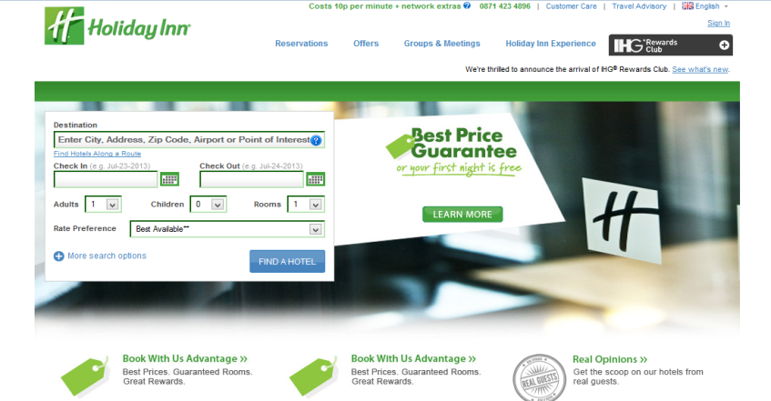

Making reservations in advanced helps the users to secure bookings 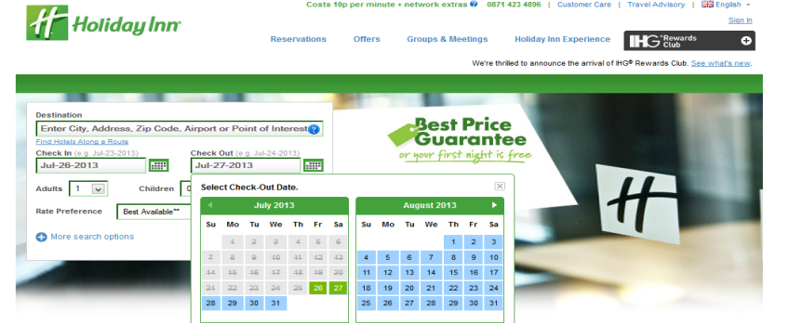

* Require to create an account before complete reservation:
* Users are required to create an account in order to complete their booking.
* Printing reservation details allows users to keep a hard copy of their reservation detail for easy check-in.

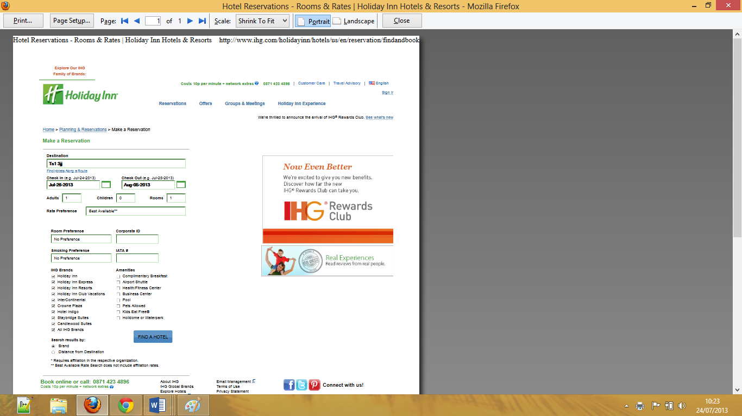

* Cancel reservation:

Users are not able to cancel reservations online. A reservation can only be cancelled by phoning the company.

* Sign up for email offers allows users to register themselves for receiving promotional offers from the company.

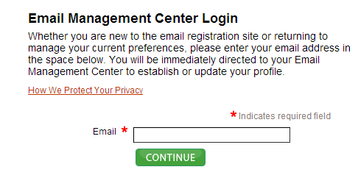

* Ability to modify customer details:

Because users are not required to create an account, there is no way to modify their details.

* Forgot password recovery:

Because users are not required to create an account, there is no way to recover a password.

* Change password:

Because users are not required to create an account, there is no way to change a password.

* Handle various currencies:

The system only accepts British pounds, so it is impossible for someone to make a payment from outside UK.

* Acceptances of various payments methods:

The user can make a payment online by using credit card, debit card and so on. Other Payments options are available in the company itself.

* Receive email confirmation upon successfully completing a booking:

Users will receive confirmation via email containing reservation details for future correspondent purposes.

* Provide information about tourist attraction places, restaurants and other marketing offers:

There is no way available for the user to find nearby tourist attractions close to the hotel.

#### Apply usability heuristics

##### Visibility

The website scores fairly well on visibility, the most important attribute is that the user gets feedback on almost all of the processes such as:

* A display indicates “searching for cheapest hotel” while the page develops rather than having the user wait on a blank screen for minutes
* Letting the user know that they have successfully registered: “You have successfully registered” appears on the screen.

##### Match between the system and real world

The website scores moderately good on this heuristic. This means that it does not speak the user’s language. The home page does not give a clear idea to its users that it is a hotel booking system. For example, there is no image of the hotel or its rooms; rather plenty texts on booking information and such are displayed.

##### User control and freedom

The website scores quite well on user control attributes as it provides very clear navigation systems to help users find appropriate pathways throughout the website.

##### Consistency and standards

The website scores fairly bad on consistency and standards; users might need to spend some time to learn how to use this system.

##### Error prevention

The website scores very good on error prevention; for example, when the user creates an account to register the system automatically checks whether the user`s email address is valid. If it is invalid the user is prompted to provide a valid email address in order to complete the registration process.

##### Recognition rather than recall

The website scores very good with recognition features. For example when a user enters the billing address and debt/visa card number, if the card number was wrong the user is required to re-enter the card number without having to enter the billing address again.

##### Aesthetic and minimalist design

The website scores fairly well on aesthetic and minimalist design concepts, its design is efficient and also statically beautiful. However, although it is quite attractive, it is not deemed utterly simple to use.

##### Help users recognise and recover from errors

The website scores very well on helping users to recognise and recover errors. For example, if user enters a wrong password in the login form, a pop-up message will appear to let the user know that the password entered is wrong.

##### Help and Documentation

The system scores fairly bad on this heuristic since there are no FAQs page in the contents, and additionally, the site has poorly labelled form fields.

### System 2-https://www.travelrepublic.co.uk

#### System’s notable issues

|  |  |
| --- | --- |
| Issues | Yes/No |
| 1. Simple GUI and user friendly 2. Make reservation in advanced 3. Require to create an account before reservation 4. Print reservation detail 5. Cancel reservation 6. Sign up for email offers 7. Ability to modify customer details 8. Forgot password recovery 9. Change password 10. Handle various currencies 11. Receive confirmation email on every successful booking 12. Provide information about tourist attraction places, restaurants and etc... | 1. Yes 2. Yes 3. Yes 4. Yes 5. No 6. No 7. Yes 8. Yes 9. Yes 10. Yes 11. No 12. No |

#### Table 2.5.2.1 Notable issues of (travelrepublic.co.uk).

#### Descriptions

* Simple GUI and user-friendly options help users to find the information they are looking for.

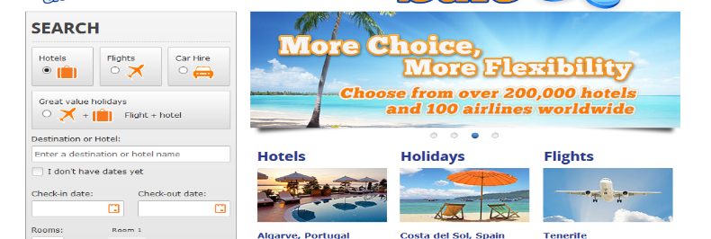

* Make reservation in advanced which helps the users to secure bookings.

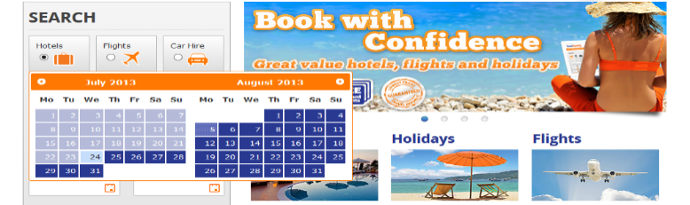

* Required to create an account before complete reservation:

Users have to create an account in order to login and complete their booking.

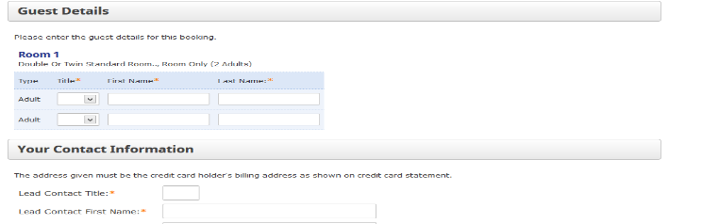

* Printing reservation details allow users to keep a hard copy of their reservation details for easy check-in.

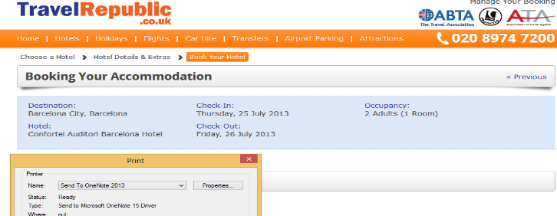

* Cancel reservation:

There is no way the user can cancel a reservation online.

* Signing up for email offers allow users to register themselves to receive marketing promotional offered by the company.

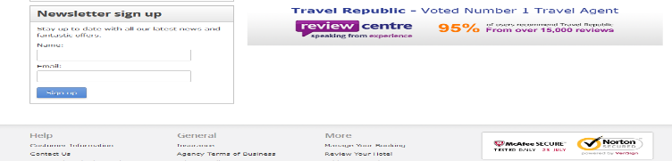

* Ability to modify customer details:

Because users are required to create an account they are able to modify their details.

* Forgot password recovery:

Because users are required to create an account they are able to recover their password.

* Change password:

Since users are required to create an account they are also able to change their password.

* Handle various currencies:

The system only accepts British pounds, so it is impossible for someone from outside UK to make a payment online.

* Tackle various languages:

The language of the system is English, so it is difficult for non-English speakers to use the system.

* Acceptances of various payment methods:

Users can make a payment online by using various bank cards. They can also make payments in the company itself.

* Receive email confirmation on every successful booking:

The user will receive email confirmation containing reservation details for future correspondence.

* Provide information about tourist attraction places, restaurants and luxury attractions:

There is no way for the user to find nearby tourist attractions in the vicinity of the hotel.

#### Apply usability heuristics



##### Visibility

The website scores quite bad on visibility, there are no feedbacks on some of the website processes, for example:

* When the user is searching for the cheapest hotel, a blank screen is displayed rather than a message letting the user know that the system is searching for available hotels.
* There is no way for the user to know whether it has successfully registered or not, instead they have to guess that the registration was successful.

##### Match between the system and real world

The website scores very good on this heuristic, which means it does speak the user’s language. The home page gives a clear idea to its users that it is a hotel booking system. For example, there are some images of hotels and rooms on most of the web pages.

##### User control and freedom

The website scores quite well on user control since it provides very clear navigations to direct users throughout the website.

##### Consistency and standards

The website does not score very well on consistency and standards; some users who are familiar with online booking may not need to spend much time before understanding how to use the system. However, uneducated users or elderly people will need some time before learning how to use it.

##### Error prevention

The website scores very good on error prevention. For example, when a user creates an account, in order to register it will check whether the user`s email address is valid. If invalid, the user has to provide a valid email address in order to complete the registration process.

##### Recognition rather than recall

The website scores very bad on recognition. For example, after a user has entered the billing address and debt/visa card number, if the card number was wrong user has to go through the entire procedure from the beginning.

##### Aesthetic and minimalist design

The website scores quite well on aesthetic and minimalist design since its design is efficient and also statically beautiful. As such it is noted as being attractive and is very simple to use.

##### Help users recognise and recover from errors

The website scores very good in regards to helping users recognise and recover errors. For example if a user enters a wrong password in the login form, a pop-up message appears to indicate that the password entered was wrong.

##### Help and Documentation

The system scores fairly well on this heuristic, there is a FAQs page which contains a lot of relevant questions and answers for the user to follow and it also contains well-labelled form fields.

## Key Technologies

### PHP (**H**ypertext **P**re-processor):

Hypertext Pre-processor (PHP) is an open source scripting language, which is suitable to develop the web applications prior to embedding it into HTML. One can simply create surveys, picture galleries, forum pages and many more with the help of this scripting language. However, this language executes at the server side(powers 2010).

### MySQL:

MySQL is a highly beneficial SQL database management system, which is available as an open source. This system is designed, and distributed through the Oracle Corporation. The relational databases can be designed through this system to store data in the form of rows and columns(DuBois 2013).

### XHTML and XML:

W3C had developed the XHTML, which can be used on a wide range of platforms. Therefore, XML can be termed as the parent for generation of XHTML. Through XML, one can mark-up the the documents easily. Through XHTML language, the programmer can use nested and closed XML tags to avoid any error(E.Holzschlag 2002).

### CSS (**C**ascading **S**tyle **S**heet):

Cascading Style Sheets is an additional tool for HTML, so that the users as well as web developers can have better control over the view of the web pages. It was developed by W3C. The elements of webpage including the links and headers can be designed through the CSS(Schmit 2010).

### Java Script:

JavaScript is a popular programming language which is useful to design interactive web pages. These run from the server and do not get downloaded at the client's end. If one wishes to design the quizzes or polls, it is an appropriate programming language for usage(Flanagan 2011).

## Software Development Methods

Software engineering makes use of certain methodologies, which serve as frameworks, based on which the information system is structured, planed and controlled (Rech and Bunse, 2009). These methodologies are known as ‘software development methods’. Basically, these methodologies are a process in which various strategies for software development are planned. It may be that a software methodology that was applicable in one project, may not work for another. However, there are cases where the same methodologies are used in other projects, too. Each methodology has its own pros and cons. There is a large variety of these software methodologies which have been developed over the years, keeping in mind various types of projects. Continue reading, if you wish to learn more about software methodologies and how they are developed.

### Waterfall model

Waterfall Model, also known as linear sequential life cycle model, is a model used when the requirements are clearly defined with a stable product definition. Under such model, the whole software development work is divided into phases, and the phase shall be completed prior to beginning the next phase. For testing purpose, the review of project is undertaken after completion of each phase. Thus, there is no overlapping of phases in this model.

### Agile Model

Agile Model is the practice based model to appropriately document and model the software system requirements. The practices, principles, and values are utilised by the software developer for the project in an effective manner. Through this model, the software developer can design the software development procedure that is ideally suited to their needs.

### Prototype Model

Under the prototyping method, a working prototype is designed for the software system, prior to beginning the actual software project. This can be termed as an instance of the software. Thus, the prototype would consist of limited set of functionalities, which are just to represent how the software would be developed at later stages. This method is ideally suited for development of large applications.

I have decide to use waterfall at the begging but I have change my mind to user agile model instead because of the following reasons:

* In waterfall model Once you complete one stage there is no going back again
* Waterfall is not very dynamic (inflexible)
* Waterfall throw problem over the wall
* In agile model you do not build the system at once rather that you develop incrementally
* In agile model changes are easy to manage
* In agile model you are in the loop every time.

## **Dijkstra’s Algorithm**

To implement one of the features of the system is finding the tourist attraction places and restaurants and fastest routes leading to them, I have used Dijestra algorithm, as it is explained bellow.

This algorithm which is named after its inventor has been very effective in path computation research. This algorithm visits each node in a graph starting with the root node and then evaluates each closest unevaluated node. The set of nodes which are yet to be examined are added to their successors and hence divides the graph in two distinct sets:

S - Set of nodes whose shortest path to root node is known

S’ - Set of nodes whose shortest path to root node is yet to be determined

If we consider the sets of nodes in a graph as tourist attraction places and hotels and the start node as the current location of the traveller then the set S’ would initially be the set of all such hotels and tourist attraction places which have not been examined yet. As the hotels and paths leading to them are examined, the set S starts growing.

A priority queue is formed in order to determine the next node to be added to the set S. The priority queue contains the nodes being examined from the set S’ and the prioritization is done by their distance label (De Villiers, 2010). This distance label is the cost of the current node’s shortest path to the start location of the traveller. This distance is known as the start distance. The location at the node u which is at the top of the priority queue is examined and is added to the set S and the out-links are relaxed for this node. If the sum of distance label of u and cost of out-links of (u, v) comes to be less than the distance label for v, this value is updated as the estimated shortest distance for node v. Then in the next iteration, the algorithm examines the next node at the top of the priority queue. This process is repeated for all the nodes in the priority queue. The algorithm comes to an end when all the nodes in the queue are examined or the queue gets empty. The hotel or tourist destination among all such locations with the shortest distance from the location of the traveller is thus returned. Dijkstra’s algorithm proves to be very useful in solving such single source shortest path problems where there is a need of computing shortest path trees from a single source node to all other nodes.

Dijkstra’s algorithm is a variant of the Breadth first search algorithm and it finds the optimal shortest path to all locations from the current location of the traveller. This algorithm doesn’t prove to be that effective when it comes to finding the shortest distance from a single start location to a single destination. Dijkstra’s algorithm also imposes relatively higher computing costs and hence more efficient computing methods employing heuristic searches were researched. A* algorithm is one of most used algorithms which is considered to be the most efficient algorithm when it comes to computing shortest path from a single sour to a single destination. Thus the use of this algorithm will help in faster calculation of distances.

# **Requirement analyse**:

## List of Requirements

### Make reservation in advance

### Create an account before make reservation

### User cancel reservation

### User view reservation

### Modify user personal detail

### User sign up for email offers

### Password recovery

### Change password

### Receive confirmation email on every successful booking

### Provide information about tourist attraction places, restaurants and etc...

### User ability to contact administrator

### View and delete reservations by administrator

### View, edit and delete rooms by administrator

### View and delete room amenities by administrator

### Read and delete user comments by administrator

### User print reservation detail

### Usability (Simple GUI and user friendly)

### Performance (how quickly system reacts to user input)

### Reliability (ability of the system to perform multiple functions)

### Maintainability (Easy to fix when brake down occurred)

### Availability (System is available to everyone at all the time)

### Accessibility (System is accessible to those users who are handicapped in some way)

### Security (Secure logging system).



## Functional Requirements

|  |  |
| --- | --- |
| Requirements | Priority  (H, M, L) |
| 1. Make reservation in advanced 2. Create an account before make reservation 3. User cancel reservation 4. User view reservation 5. Modify user personal detail 6. User sign up for email offers 7. Password recovery 8. Change password 9. Receive confirmation email on every successful booking 10. Provide information about tourist attraction places, restaurants and etc... 11. User ability to contact administrator 12. View and delete reservations by administrator 13. View, edit and delete rooms by administrator 14. View and delete room amenities by administrator 15. Read and delete user comments by administrator 16. User print reservation detail | 1. H 2. H 3. H 4. H 5. H 6. L 7. H 8. H 9. H 10. H 11. M 12. H 13. H 14. H 15. H 16. M |

#### Table 3.2 Functional requirements.

## Non-Functional Requirements

|  |  |
| --- | --- |
| Requirements | Priority  (H, M, L) |
| 1. Usability (Simple GUI and user friendly) 2. Performance (how quickly system reacts to user input) 3. Reliability (ability of the system to perform multiple functions) 4. Maintainability (Easy to fix when brake down occurred) 5. Availability (the system is available to everyone at all the time) 6. Accessibility (System is accessible to those users who are handicapped in some way ) 7. Security (Secure logging system) | 1. H 2. H 3. H 4. H 5. H 6. H 7. H |

#### Table 3.3 Non-Functional requirements.

# Design

## Database

### Overview

Any collection of organized information which can be managed and accessed easily and is kept up to date will be considered as a ‘database’ (Coronel and Rob, 2009). Based on the different types of content, we can classify these databases. The content may be bibliographic or full text or it may even contain numeric and images.

However, in computing, databases are classified differently. They are classified on the basis of the organizational approaches that they have. The most common approach is that of the relational database, which is a tabular database which stores and defines data, so that it becomes recognizable and accessible in various ways (Rahimi and Haug, 2010).

Data files are an important part of the database management system (DBMS). Data files are used for storing database information. Index files and data dictionaries are other types of files, which store information which is known as ‘metadata’. Metadata is basically the administrative information. One of the main advantages of using a database is that all your data can be stored in one single place (Coronel and Rob, 2009). Details like ‘titles’ are required to be updated just once in the ‘CMS’ and then you are set as the change will propagate itself throughout the entire website, wherever or whenever that particular title is displayed.

### Data Dictionary

‘Data Dictionary’ is a term used for describing a collection which deals with data stores. Not only the data stores, but the Data Dictionary also deals with the structures which are within these stores and their elements as well. The information which is stored in these dictionaries is used for creating ‘outline constraints’ which prove to be beneficial during the creation of the database. Each and every data store will be having its own structures as well as elements. The database field entry will be included in the structure (Sumathi and Esakkirajan, 2007). For example, a particular ‘customer data store’ will be having its own ‘customer structure’. The structures will also contain the element within them. When creating the database, these elements need to be further elaborated upon so that their different field sizes and data types can be defined. The biggest advantage of using a data dictionary is that they help is pre defining specific database characteristics, so that the final database remains unchanged, consistent (Doyle, 2000). In short, there will hardly be any errors or mistakes in the relationships where one particular table has a different ‘field size’ as compared to the other table to which it is linked with. This strategy is greatly beneficial for the developers of tomorrow, who can read these details and facts before they start programming.

The key for the dictionary’s letters is $ for [A...Z] and numbers are # for [0...9]

#### Customer

|  |  |
| --- | --- |
| STRUCTURES | |
| Name | **Contained elements/sub-structures** |
| Customers | @id, full name ,username ,address ,city ,country ,postcode ,email ,password ,contact |

*Table 4.1.2.1(a) Structure of customer table.*

|  |  |  |
| --- | --- | --- |
| ELEMENTS | | |
| Name | **Data type & limits** | **Data Integrity** |
| @id | 11{int} | * Customer id ########### |
| full name | 34{varchar} | * Customer fullname $$$... |
| Username | 34{varchar} | * Customer username $$$... |
| Address | 54{varchar} | * Customer address $$$... |
| City | 34{varchar} | * City or town name $$$... |
| Country | 34{varchar} | * Country name $$$... |
| Postcode | 8{varchar} | * Post code $$$$$$$$ |
| Email | 34{varchar} | * Customer email $$$... |
| Password | 34{varchar} | * Customer password $$$...  md5 auth password |
| Contact | 11{int} | * Customer contact number ########### |

*Table 4.1.2.1(b) Elements of customer table.*

#### Room

|  |  |
| --- | --- |
| STRUCTURES | |
| Name | **Contained elements/sub-structures** |
| Rooms | @id,hotel_name,type_of_room,description ,image_of_rooms ,max_quantity ,adult_capacity ,child_capacity ,price |

*Table 4.1.2.2(a) Structure of room table.*

|  |  |  |
| --- | --- | --- |
| ELEMENTS | | |
| Name | **Data type & limits** | **Data Integrity** |
| @id | 11{int} | * Room id ########### |
| hotel_name | 34{varchar} | * Hotel name $$$... |
| type_of_room | 34{varchar} | * Type of room $$$... |
| description | 54{varchar} | * Room description $$$... |
| image_of_rooms | 54{varchar} | * Room image $$$... |
| max_quantity | 11{int} | * Quantity of room ########### |
| adult_capacity | 11{int} | * Max adults ########### |
| child_capacity | 11{int} | * Max children ########### |
| Price | 11{varchar} | * Price of room $$$$$$$$$$$ |

*Table 4.1.2.2(b) Elements of room table.*

#### Reserved room

|  |  |
| --- | --- |
| STRUCTURES | |
| Name | **Contained elements/sub-structures** |
| Reserved room | @re_id,@id,arrival,departure,number_reserved,booking_ref_no |

*Table 4.1.2.3(a) Structure of reserved room table.*

|  |  |  |
| --- | --- | --- |
| ELEMENTS | | |
| Name | **Data type & limits** | **Data Integrity** |
| @re_id | 11{int} | * Reserved room id ########### |
| @id | 11{int} | * Room id ########### |
| Arrival | 34{varchar} | * Arrival date $$$... |
| Departure | 34{varchar} | * Departure date $$$... |
| number_reserved | 11{int} | * Number of reserved room ########### |
| booking_ref_no | 11{int} | * Booking reference number ########### |

*Table 4.1.2.3(a) Elements of reserved room table.*

#### Booking

|  |  |
| --- | --- |
| STRUCTURES | |
| Name | **Contained elements/sub-structures** |
| Booking | @id, username,arrival,departure,no_of_adults,no_of_children,no_of_rooms,  type_of_room,booking_ref_no |

*Table 4.1.2.4(a) Structure of booking table.*

|  |  |  |
| --- | --- | --- |
| ELEMENTS | | |
| Name | **Data type & limits** | **Data Integrity** |
| @id | 11{int} | * Booking id ########### |
| Username | 34{varchar} | * Customer username $$$... |
| Arrival | 34{varchar} | * Arrival date $$$... |
| Departure | 54{varchar} | * Departure date $$$... |
| no_of_adults | 11{int} | * Number of adults ########### |
| no_of_ children | 11{int} | * Number of children ########### |
| no_of_rooms | 11{int} | * Number of rooms ########### |
| type_of_room | 54{varchar} | * Type of room $$$... |
| booking_ref_no | 11{varchar} | * Booking reference number $$$$$$$$$$$ |

*Table 4.1.2.4(a) Elements of booking table.*

#### Admin

|  |  |
| --- | --- |
| STRUCTURES | |
| Name | **Contained elements/sub-structures** |
| Admin | @id, fullname,email,username,password,position |

*Table 4.1.2.5(a) Structure of admin table.*

|  |  |  |
| --- | --- | --- |
| ELEMENTS | | |
| Name | **Data type & limits** | **Data Integrity** |
| @id | 11{int} | * Admin id ########### |
| Fullname | 34{varchar} | * Admin full name $$$... |
| Email | 34{varchar} | * Admin email address $$$... |
| Username | 34{varchar} | * Admin username $$$... |
| Password | 34{varchar} | * Admin password $$$...  md5 auth password |
| Position | 34{varchar} | * Admin position $$$... |

*Table 4.1.2.5(b) Elements of admin table.*

#### Comment

|  |  |
| --- | --- |
| STRUCTURES | |
| Name | **Contained elements/sub-structures** |
| comment | @id, customer_name,email,booking_ref_no,message |

*Table 4.1.2.6(a) Structure of comments table.*

|  |  |  |
| --- | --- | --- |
| ELEMENTS | | |
| Name | **Data type & limits** | **Data Integrity** |
| @id | 11{int} | * Comment id ########### |
| customer_name | 34{varchar} | * Customer full name $$$... |
| email | 34{varchar} | * Customer email address $$$... |
| booking_ref_no | 11{varchar} | * booking reference number $$$$$$$$$$$ |
| message | {text} | * Customer comments $$$... ###... |

*Table 4.1.2.6(b) Elements of comments table.*

#### Routes (Walk)

|  |  |
| --- | --- |
| STRUCTURES | |
| Name | **Contained elements/sub-structures** |
| routes | @id, from_,to_,distance ,time |

*Table 4.1.2.7(a) Structure of routes (walk) table.*

|  |  |  |
| --- | --- | --- |
| ELEMENTS | | |
| Name | **Data type & limits** | **Data Integrity** |
| @id | 11{int} | * Route id ########### |
| from_ | 34{varchar} | * Start name $$$... |
| to_ | 34{varchar} | * Destination name $$$... |
| distance | 11{int} | * Distance between start and destination ########### |
| time | {time} | * Time taken between start and destination ###... |

*Table 4.1.2.7(b) Elements of routes (walk) table.*

#### Routes1 (Drive)

|  |  |
| --- | --- |
| STRUCTURES | |
| Name | **Contained elements/sub-structures** |
| Routes1 | @id, from_,to_,distance ,time |

*Table 4.1.2.8(a) Structure of routes (drive) table.*

|  |  |  |
| --- | --- | --- |
| ELEMENTS | | |
| Name | **Data type & limits** | **Data Integrity** |
| @id | 11{int} | * Route id ########### |
| from_ | 34{varchar} | * Start name $$$... |
| to_ | 34{varchar} | * Destination name $$$... |
| distance | 11{int} | * Distance between Start and destination ########### |
| time | {time} | * Time taken between start and destination ###... |

*Table 4.1.2.8(a) Elements of routes (drive) table.*

### Table normalisation

When the database is in its ‘first normal form’ it will have a big collection of tables which may contain data which is inessential and often repeated. However, once the normalisation has been done, the data is represented in a well organised form with the improvement in quality of data and with the deletion of redundant data (Ritchie, 2008). Gradually, the data moves a step further and becomes the ‘second normal form’ which needs to evolve into a ‘third normal form’. It is the third normal from which is going to serve as a basis upon which a good, ‘relational database’ can be built. The fields that depend on some other field too, besides the primary key, is removed to form another table.

After getting every specific table identified, along with its fields, the table can no longer have any fields on the basis of which it can be identified as unique.

### Database background

#### Constraints

While programming the database, if you assume that the ‘front end application’ is the one which is going to handle the data’s integrity, then you are plain wrong. For this purpose, there are certain rules developed which the data entries should abide by. ‘Data types’ and ‘entry lengths’ have rules which work with reference to the ‘primary key’ and ‘foreign key’ constraints (Sumathi and Esakkirajan, 2007). These keys allow the relational database to link fields so that it can share data. On the other hand, the ‘data constraints’ make sure that fields of various tables are similar. ‘Integrity constraints’ are also there whose purpose is to ensure that data entries are according to the purpose for which they were meant.

#### Triggers and procedures

Triggers in a database are utilised when updates need to be automatic. A prime example would be where a company requires a backup copy of an invoice, or a generic cascade delete function.

### Entity Relationship Diagram (ERD)

The entity relationship diagram (ERD) shows the tables and the relationships, for example the relations (connections) between primary key and foreign key. It is used as the basis upon which to create table constraints.

The diagram shows the tables, primary key(s), foreign key(s) and composite key(s), the red dot indicate the primary key and the blue dot indicate the composite key.

Routes1 (Drive)

Routes (Walk)

*Id

from

to

distance

time

*Id

from

to

distance

time

Admin

Customers

*ad_Id

full name

username

password

position

*cust_Id

full name

username

address

city

country

postcode

email

password

contact

1..1

0..*

Comment

1..*

0..*

1..1

*co_Id

*cust_Id

customer_name

email

booking_ref_no

Message

1..*

Booking

*bo_Id

*cust_Id

*ad_Id

username

arrival

departure

no_of_adults

no_of_children

no_of_rooms

type_of_room

Booking_ref_no

Room

Reserved_room

*room_Id

*bo_Id

hotel_name

type_of_room

description

image_of_room

max_quantity

adult_capacity

child_capacity

Price

### 

**\***re_Id

*room_id

arrival

departure

number_reserved

Booking_ref_no

1..*

1..*

1..*

1..*

*Figure 4.1.5 Entity relationship diagram*

**Customer to Booking 0..*:** Customer can exist without booking or can have many

**Booking to Customer 1..1:** Booking must have a customer and only one customer

**Admin to Booking 1..*:** Admin can manage one or many booking

**Booking to Admin 1..*:** Booking can be managed by only one admin or many

**Room to Booking 1..*:** Each room can have one or many booking

**Booking to Room 1..*:** Booking must have a room or many

**Customer to Comment 0..*:** Customer will send none or many comments

**Comment to Customer 1..1:** Comment must have a customer (sender) and only one customer

**Room to Reserved_room 1..*:** Each room can have one or many reserved_room

**Reserved_room to room 1..*:** Reserved_room must have a room or many

There is no relation between the (routes and routes1) and the rest of tables therefor they have not participate in the EDR (Entity Relationship Diagram).

Routes and routes1 are used to find fastest route between start point and destination point as well as calculate distance and time taken between each points.

### Platform selection

There are many database management systems present, like for example, MSSQL, oracle and even MySQL. Developers consider MSSQL and MySQL to be the two most prominent ones. If you want to opt for MSSQL, make sure that you are aware of its cost, as it is expensive because of its complicated hardware specification (Watteville and Gilbert, 2000). If you are looking for a less expensive option, then MySQL would be a good idea. However, if you can afford, then always opt for MSSQL system as it has several features and capabilities. MySQL, on the other hand has a number of limitations.

### Query optimisation

When you try to link a database with the front end of a website, it might lower down your download speed. SQL server lets the stored procedures to be made use of which in turn makes the databases’ function better (Brown and Smith, 2012). However, this step alone will not be enough to optimize a specific database; as mentioned earlier, the table should be normalised at least till the ‘third normal form’.

## Website

### Discussion

Whatever has been discussed up to this point was in relation with either the ‘backend’ or with the processing of the data which is going to be stored. Now, from here onwards, the front end issues will be focused on more.

#### Web standards

Every procedure has its own guidelines which need to be followed. Similarly, when you sit down to create a website; there are a few rules which are going to be governing the process (Rob andCoronel, 2009). There are two important rules/guidelines which will be governing the process of creating a website:

The WAI Guidelines: WAI is shorthand for Web Accessibility Initiative and their purpose is to make sure that users which have different abilities, all of them are able to use a website.

Mark Up Validation Service: The mark up validation service is concerned with checking the coding and the standards of ‘style sheet coding’ to make sure that browsers will be able to read a particular site properly (Ritchie, 2002).

#### Web Evolution

Nothing is ever constant and the same can be applied to the internet and the website, which have constantly been going through one change after another. From the way websites are programmed to the way they are displayed----all of this has been constantly changing. In the past, simplicity was stressed upon, simple pages were in demand (Rahimi and Haug, 2010). However, in the present, when it comes to web programming, Web 2.0 takes the front lead. It uses AJAX which updates the content of a page, directly from the database, without there being any need for loading or reloading. As a result, the page becomes more responsive.

#### Layout and design

Layout and design are equally important as the content of a website. However, if you site is more focused on the content, then a good move would be to keep the layout and designs as simple as possible, so that when a visitor, visits your website, he may not get distracted by the flashy graphics and ignore the content on which you worked so hard on (Doyle, 2000). Then, again, if your site has too much of content, and no graphics, then it may come across as boring. So, the key here is to strike a balance, between the right amounts of content, while making the webpage look attractive with a few good graphics and of course, a proper layout. One important thing to remember is that the website’s main area should be kept as simple as possible, so that even those people who are not that computer literate, they, too, can find their way and manage using the website. Try incorporating large buttons and simple menus to help such users.

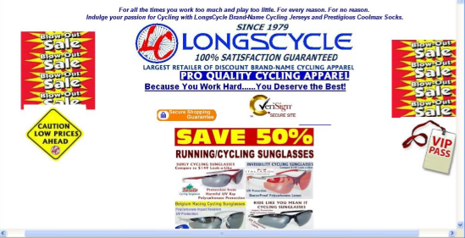

*Figure 4.2.1.3 Bad Web Design*

Figure 4.2.1.3 gives you a very clear picture of what you should NOT do when you are designing a web page. If you observe, you will notice several things which are damaging to its usability. It neither had a clear theme nor can any flow of colour scheme be observed. It has a non-existent navigation system and overall presentation of the information is poor. To conclude, rather than drawing visitors, it is going the exact opposite: making them leave!

### Navigation chart

Home

User-login

Add room

Modify room

Delete room

Confirm

Rooms

Delete reserved room

Reserved room

Delete reservation

Reservations

Read customer comments

Delete customer comments

Customer comments

Admin area

Admin-login

Print reservation

Cancel reservation

Change password

View reservation

Modify user detail

User area

Routes

Contact us

Select room

Forgot password

Register

View booking Info

*Figure 4.2.2 Navigation Chart*

## Initial requirements analysis of user interaction

### Initial ideas for a GUI

#### Home page structure

*Side bar*

*Content*

*Navigation bar*

*Figure 4.3.1.1 Home page structure*

* **Navigation bar**: This is a set of buttons at the top of webpages which contains hypertext links that allows the user to navigate between all the pages of the website, including:

1. Home
2. Register
3. Contact us
4. Routes
5. Admin

* **Side bar**: This is an initial step of the typical booking process which contains a list of requirements for the booking in the form of dropdown lists such as:

1. Check-in date
2. Check-out date
3. Number of adults
4. Number of children
5. Number of rooms

* **Content**: This includes texts, links, graphics and other information. The Home page content contains an image of the hotel to attract the end-users of the system.

#### Register page structure

*Side bar*

*Content*

*Navigation bar*

*Figure 4.3.1.2 Register page structure*

* **Navigation bar**: it is set of buttons at the top of webpages which contains hypertext links to navigate between all the pages of the website which includes:

1. Home
2. Register
3. Contact us
4. Routes
5. Admin

* **Side bar**: Side bar on the Registration page contains:

1. My booking: This displays the current booking process by the end-user such as:

* Check-in date
* Check-out date
* Number of adults
* Number of children
* Number of rooms
* Type of room

1. My account: This requires the user to login to access their account which includes:

* MyDetail: View and modify personal details
* MyReservation: View reservation details
* CancelReservation: Cancel a reservation
* ChangePassword: Change user`s login password
* Print : Print user`s detail as well as reservation details
* **Content**: Registration page content contains a form whereby the user submits required details to create an account in order to login. Register form includes:
* Full name
* User name
* Address
* City
* Country
* Post code
* Email
* Re-type email
* Password
* Contact numbe

#### Routes page structure

*Content*

*Navigation* *bar*

*Figure 4.3.1.3 Routes page structure*

* **Navigation bar**: This is a set of buttons at the top of webpages which contains hypertext links to navigate between all of the pages on the website which includes:

1. Home
2. Register
3. Contact us
4. Routes
5. Admin

* **Content:** The Content of navigational routes page contains the following details:

1. Inputs

* From: Dropdown list to select start place
* To: Dropdown list to select destination place
* Avoid: Dropdown list to select the place to avoid
* Via: Dropdown list to select the place to go via

1. Outputs

* Calculate and display the distance
* Calculate and display the time taken by walk and by drive
* Display the routes between selected start and destination

1. Map: This includes surrounding hotels, tourist attractions and restaurants, as well as streets and road names between them.

#### My detail page structure

*Side* *bar*

*Content*

Navigation bar

*Figure 4.3.1.4 My detail page structure*

* **Navigation bar**: This is a set of buttons at the top of webpages which contains hypertext links to navigate between the user-area pages of the website and includes:

1. My detail
2. My reservation
3. Cancel reservation
4. Change password
5. Print

* **Side bar**: The side bar on the My Detail page is similar to the navigation bar which contains:

1. My detail
2. My reservation
3. Cancel reservation
4. Change password
5. Print

* **Content**: My detail page content displays the user`s detail which includes:

1. Full name
2. Address
3. City
4. Post code
5. Email address
6. Contact number
7. Edit (which allows the user to edit and modify their details)

#### My reservation page structure

*Side bar*

*Content*

*Navigation bar*

*Figure 4.3.1.5 My reservation page structure*

* **Navigation bar**: This is a set of buttons at the top of webpages which contains hypertext links to navigate between the user-area pages of the website which includes:

1. My detail
2. My reservation
3. Cancel reservation
4. Change password
5. Print

* **Side bar**: The side bar on the My detail page is similar to navigation bar which contains:

1. My detail
2. My reservation
3. Cancel reservation
4. Change password
5. Print

* **Content**: The My Reservation page content displays reservation details which includes.

1. Arrival
2. Departure
3. Room type
4. Adult Name
5. Child Name
6. Rooms
7. Booking reference number

#### Change password page structure

*Side bar*

*Content*

*Navigation bar*

*Figure 4.3.1.6 Change password page structure*

* **Navigation bar**: This is the set of buttons at the top of webpages which contains hypertext links and allows users to navigate between the user-area pages of the website, it includes:

1. My detail
2. My reservation
3. Cancel reservation
4. Change password
5. Print

* **Side bar**: The side bar on the Change Password page is similar to the navigation bar which contains:

1. My detail
2. My reservation
3. Cancel reservation
4. Change password
5. Print

* **Content**: The Change Password page contains the following input requirements:

1. Current password
2. New password
3. Repeat new password

#### Rooms page structure

*Side bar*

*Content*

*Navigation bar*

*Figure 4.3.1.7 Rooms page structure*

* **Navigation bar**: This is the set of buttons at the top of webpages which contains hypertext links that allows users to navigate between the admin-area pages of the website, and includes:

1. Customer comments
2. Reservation
3. Reserved room
4. Rooms

* **Side bar**: The side bar on the Rooms page is similar to the navigation bar which contains:

1. Customer comments
2. Reservations
3. Reserved room
4. Rooms

* **Content**: The Rooms page content displays the rooms in which admin has the ability to add, delete or edit details of a room at any time, this includes:

1. Type of room
2. Hotel name
3. Description
4. Rooms
5. Quantity
6. Adult capacity
7. Child capacity
8. Edit (which allows the administrator to edit or modify room details)
9. Delete (which allows the administrator to delete rooms from the system`s database)
10. Add (which allows the administrator to add a room to the system`s database)

### Use cases

Use case define how the system will solve problem or provide some level of functionality and also define what is required of the system and how those requirement will be met .

**Admin**

**User**

**v**

*Figure 4.3.2 Use case Diagram*

#### Description

* User select check-in, check-out date, number of adults and children, as well as number of rooms;
* User search for available room based on required details;
* User select a room to reserve;
* User has to create an account/register and login in order to continue;
* User can view and modify account details as well as view and cancel reservation;
* User able to change current password;
* If user forgot current password, new password will be sent to the user`s email address;
* User can contact the administrator via contact-us form;
* User can find tourist attractions and restaurants nearby the hotel as well as identify distance and time taken to each place;
* Admin can add/modify and delete rooms form the database;
* Admin can view all users and has ability to delete them;
* Admin can view and delete reserved rooms from the database;
* Admin can view list of customer that have sent comments to admin and read them one by one.

#### Actors

* User
* Admin

#### Pre-conditions

* User goes to the online booking webpage in their personal browser
* Logging in to the system.

#### Post-conditions

If use case was successful, the reserved room is stored in the system`s database or the system`s state remains unchanged.

### Activity diagrams

Activity diagram gives a dynamic view of the system. Below are the activity diagrams with explanations of each of the following:

#### Finding the shortest distance

User selects starting point (the hotel) and destination (place of interest/ tourist attraction) from dropdown list and searches for the fastest route. When the fastest route is found by the system, the distance and time taken will be displayed for walking and driving options.

* User can also select via, avoid, or both to find fastest route from start to destination.
* If via selected in the dropdown list, the route will go through that particular place.
* If avoid is selected in the dropdown list, the route will avoid that particular place.
* If via and avoid are both selected they can be used to find fastest route at the same estimated time of arrival.

Invalid input

Ok

Invalid input

Ok

Ok

Ok

Invalid input

Invalid input

*Figure 4.3.3.1 Find shortest distance*

#### Room booking process

When the user selects the required details (check-in, check-out date, number of adult, number of children and number of rooms) on the Home page and searches for rooms, the available rooms will be listed or will the system will display “no available rooms”.

When a particular room has been selected, the user has to login or create an account to in order to continue. By confirming the reservation at the last step of the reservation, details will be stored in the system`s database and a confirmation email will automatically be sent to the user`s email address.

Not available room

Ok

Invalid login

*Figure 4.3.3.2 Room booking process*

#### Register process

User has to register or create an account to complete booking process. All required fields must be entered and the email address has to be valid in order to proceed.

When the form is submitted, the user`s details will be stored in system`s database and a confirmation email will be sent to user`s email address.

Invalid email

All fields are required

Ok

*Figure 4.3.3.3 Register process*

#### Modify user detail

By logging in to the system, the user will be able to review personal details as well as edit and change personal

Invalid login

Ok

*Figure 4.3.3.4 Modify user detail*

#### Cancel reservation

By logging in to the system, the user will be able to view reservation details or cancel reservation.

Invalid email

Ok

*Figure 4.3.3.5 Cancel reservation*

#### Forgot Password

There is a possibility that the user may forget the login password. In this case, by submitting the user`s email address, the system will pick up the user`s username and password and email it to provided email address.

Email does not match

Ok

*Figure 4.3.3.6 Forgot password*

#### Change password

User may decides to change their login password for some reason, by logging in to the system and typing the current password and new password. The login password will be changed and the system will automatically log the user out.

Invalid login

Ok

*Figure 4.3.3.7 Change password*

#### Admin manage reservation

Another actor that interacts with the system besides the user is the administrator.

The administrator will have a username and password to login in to the system where he/she can view all the reservations and delete them at any time.

Invalid login

Ok

*Figure 4.3.3.8 Admin manage reservation*

#### Admin manage rooms

When admin logs in they are also able to access the available rooms where rooms can be added, deleted or edited as needed.

* Adding a room will insert a new room in to system`s database.
* Deleting room will remove that room from system`s database.
* By edit the room, the administrator will enable edits to modify any details which will be saves to the system`s database.

Invalid login

Ok

*Figure 4.3.3.9 Admin manage rooms*

#### Manage user comments

When a user submit a comment from the Contact Us form, the administrator will access the comments and be able to read or delete them if necessary.

Invalid login

Ok

*Figure 4.3.3.10 Manage user comments*

# Implementation

## Login

It is necessary to have two login areas, one of them is a user (customer) login area and the other is the administrator’s login.

## Customer login area

The customer/user will enter a username and password to login in to the Customer login area. If the username and password exists in the database customer table, it will allow the customer to access customer login area:

*$SqlQuery = "SELECT username, password FROM $customer_table ";*

When a customer has successfully logged in, only the details belonging to that particular customer are shown.

So the SQL query has to be written as follow:

*$ SqlQuery = "SELECT username, password FROM $customer_table WHERE username = '$username'";*

## Admin login area

Admin will enter their username and password to login in to admin area. If the username and password already exists in the database admin table, it will allow admin to access the admin login area:

*$SqlQuery = "SELECT username, password FROM $admin_table ";*

When admin has successfully logged in, the details belonging to all existing customers are shown.

So there is no need to use where statement in SQL query:

*$SqlQuery = "SELECT username, password FROM $admin_table ";*

## Sessions

It is quite important to use sessions because of the following reasons:

* Some of the page logins need to be held in order to use them;
* For security reasons, sometimes there is some information which needs to be hidden from non-registered users;
* In creating an account before completing a booking.

*SESSION_START();*

*if(!isset($_SESSION['username']))*

*{*

*die("You are required to login to access this page");*

*}*

## Available rooms

It is not realistic that customer may try to book a room while it has already been booked by someone else, hence, it is necessary that a booked room should be indicated as “*not available”*.

*if ($sum_of_no_rooms > 0){*

*echo '<td><input name="id_of_room" type="checkbox"*

*value="' .$row["id"]. '" />';echo "\n";*

*echo '<input type="submit" name="Submit" value="reserve"*

*onclick="calculator(this.form);</td>"/>';*

*}*

*if ($sum_of_no_rooms <= 0){*

*echo '<td><span class="style5">'.'Not Available'.'</span></td>';*

*}*

## Send data to database

When a user successfully registers an account, the user details will be sent to system`s database and stored in the customer table. Additionally, when a user makes a booking, the booking details will be sent to system`s database and stored in a booking table.

Send user booking to booking table:

*if (!isset($_POST['submit'])) {*

*$con = mysql_connect("localhost","root","12teesside");*

*mysql_select_db("hotel_booking", $con);*

*$my_Query="INSERT INTO booking (username,arrival, departure, no_of_adults, no_of_children,no_of_rooms ,type_of_room,booking_ref_no)*

*VALUES*

*('".$_SESSION['username']."','".$_SESSION['from']."','".$_SESSION['to']."','".$_SESSION['adults']."','".$_SESSION['child']."','".$_SESSION['rooms']."','".$_SESSION['type_of_rooms']."','$booking_number')";*

*if (!mysql_query($my_Query,$con))*

*{*

*die('Error: ' . mysql_error());*

*}}*

*mysql_close($con)*

## Retrieve data from database

When the user logins in to user login area he/ she is able to view personal and reservation details. Similarly, in the admin login area there is capacity to view/delete rooms and retrieve data from the system`s database.

Retrieve user booking from booking table:

*$connect_db = mysql_connect($Host, $User, $Password);*

*$Query = "SELECT * FROM $booking_table WHERE username = '$username' ";*

*$Result = mysql_db_query ($DBName, $Query, $connect_db);*

*while($_SESSION = mysql_fetch_array($Result))*

*{*

*echo"<td>" .$_SESSION['username'</td>";*

*echo"<td>".$_SESSION['arrival']."</td>";*

*echo"<td>".$_SESSION['departure']. "</td>";*

*}*

*mysql_close($connect_db );*

## Booking ref number

It is very important that every successful booking should have a booking reference number in case of two or more bookings at the same. This helps the user to distinguish between her/his list of bookings.

*function booking_ref_raNo() {*

*$varchr = "023456789abcdefghijkmnopqrstuvwxyz";*

*srand((double)microtime()*1000000);*

*$x = 0;*

*$abcde = '' ;*

*while ($x <= 7) {*

*$no = rand() % 33;*

*$basket = substr($varchr, $no, 1);*

*$abcde = $abcde . $basket;*

*$x++;*

*}*

*return $abcde;*

*}*

*$booking_number = booking_ref_raNo();*

## Send confirmation email

|  |  |
| --- | --- |
| Mail To | The email address of the recipient(s) |
| Mail Subject | The title of the email |
| Mail body | Booking details |

Email confirmation for very successful booking will be sent to user`s email address which contains booking details as well as a confirmation reference number.

*$mail_To = $email;*

*$mail_Subject = "Reservation notification From Online Booking System";*

*$mail_Body = "Full Name: $_SESSION['fullname'] ".*

*"Check-in date: $_SESSION['from'] ".*

*"Check-out date: $_SESSION['to'] ".*

*"Number of adults: $_SESSION['adults'] ".*

*"Number of child: $_SESSION[ 'child'] ".*

*"Number of rooms: $_SESSION['rooms'] ".*

*"Type of room: $_SESSION['type_of_room'] ".*

*"Booking_ref_no: $booking_number ";*

*mail($mail_To, $mail_Subject, $mail_Body);*

## Change password

In order to change login password, the user must submit the current password and a new password must be created to replace the current password. If the new submitted password is equal to user`s current password in the system`s database then the new password will be replace by the current password.

*$tt = mysql_query("SELECT password FROM customers WHERE username='$login '") ;*

*$row = mysql_fetch_assoc($tt);*

*$dbcurrentpassword = $row['password'];*

*if ($currentpassword==$dbcurrentpassword)*

*{*

*if ($newpassword==$repeatnewpassword)*

*{*

*$querychange = mysql_query("UPDATE customers SET password='$newpassword' WHERE username='$login '");*

## Forgot password

|  |  |
| --- | --- |
| Email | The email address of the recipient(s) |
| Subject | The title of the email |
| Header | The sender of the email |
| Content | User password |

Users will be required to submit a current email address in the case the login password is forgotten. If a user already exists in the database with a particular email address then the user`s password will be selected and sent to the submitted email address. If the email address does not exist then an error message will be generated “invalid email address, please try again”.

*if(isset($_POST['submit'])) {*

*$db_qry="SELECT `username`, `password` FROM `customers` WHERE `email` ='$email'";*

*$db_res = mysql_query($db_qry);*

*if(mysql_affected_rows() != 0)*

*{*

*$db_row=mysql_fetch_array($db_res);*

*$password=$db_row["password"];*

*$email=$db_row["username"];*

*$subject="your password";*

*$header="from:omed@onlinebookingsystem.com";*

*$content="your password is ".$password;*

*mail($email, $subject, $db_row, $header);*

*print "Your password has been sent to your email address"; }*

*else {*

*print("invalid email address. please try again."); } }*

## Data manipulations (Add, edit and delete)

### Add rooms

When admin inputs new room details in order to add a new room, the new room`s detail will be sent using post variable and inserted into the system`s database in the Room table.

*$type_of_roomofroom=$_POST['type_of_room'];*

*$description=$_POST['description'];*

*$quantity=$_POST['max_quantity'];*

*$adult_capacity=$_POST['adult_capacity'];*

*$child_capacity=$_POST['child_capacity'];*

*$insert=mysql_query("INSERT INTO*

*room (type_of_room, description, image_of_rooms,max_quantity,adult_capacity,child_capacity)*

*VALUES('$type_of_roomofroom','$description','$loc','$quantity','$adult_capacity','$child_capacity')";*

### Edit type of room

When admin modifies the type of room, it will be selected to be edited and then replaced with the new data input.

*$Query = "SELECT type_of_room FROM $room_table WHERE id= $id";*

*$Result = mysql_db_query ($DBName, $Query, $connect_db);*

*$_SESS = mysql_fetch_array($Result);*

*$type_of_room=$_SESS['type_of_room'];*

*if(isset($_POST['save']))*

*{*

*$type_of_room_save=$_POST['type_of_room'] ;*

*mysql_query("UPDATE $room_table SET type_of_room ='$type_of_room_save',*

*WHERE id = '$id'")*

*;*

### Delete room

It will pick up a room and delete it from syatem`s database.

*$Result = mysql_db_query ($DBName, $Query, $connect_db);*

*mysql_query("DELETE FROM $booking_table WHERE id = '$id'")*

## Dijkstra algorithm

One of the features of the system is to find the tourist attraction places and restaurants and fastest routes leading to them. Once the start point (hotel) and destination (tourist place or restaurant) has been selected from the dropdown list the algorism will find the shortest route and calculate the distance and time has taken

*$start=$_GET['from'];*

*$destination_=$_GET['to'];*

*$avoid=$_GET['avoid'];*

*$via=$_GET['via'];*

*('<font color="brown">('.$start.')</font>');*

*if(($start==$destination_) || (isset($_GET['avoid']) && $_GET['avoid']==$destination_) ||*

*(isset($_GET['avoid']) && $_GET['avoid']==$start) ||*

*(isset($_GET['via']) && $_GET['via']==$destination_) || (isset($_GET['via']) &&*

*$_GET['via']==$start)){*

*}else{*

*if(isset($_GET['avoid'])){*

*$res_query = mysql_query("SELECT from_,to_,distance FROM routes WHERE from_!='$avoid' && to_!='$avoid'");*

*}else{*

*$res_query = mysql_query("SELECT from_,to_,distance FROM routes");*

*}*

### Start to destination

Find shortest distance from one node to another node.

Below is the shortest route from City star hotel (start point) to Museum (destination point) through deferent numbers of nodes

*Nodes between start and destination*



*Start and Destination nodes*

*Figure 5.13.1(a) Routes between start and destination*

At the same time the system will find the distance between start point and destination point as well as the time taken by drive or by walk.

In the above example the distance between City star hotel and Museum and the time taken will be as follow:

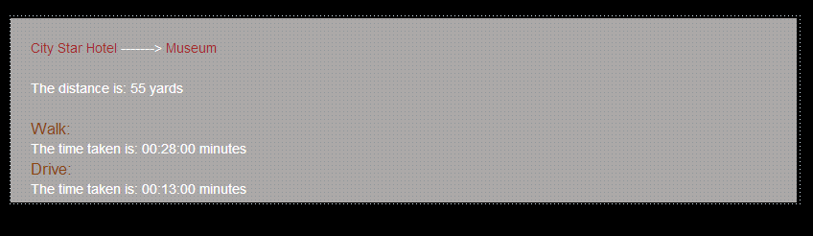

*Figure 5.13.1(b) Distance and time taken between Start and destination*

### Start to destination (Via)

Find shortest distance from node to node via another node.

Via could be tourist places (hotel, museum, parks or restaurant) or it could be roads.

#### Start to destination via tourist places

Below is the shortest route from City star hotel (start point) to Museum (destination point) via Central park (tourist place) through deferent numbers of nodes.

**

*Tourist place*

*Figure 5.13.2.1 Start to destination via tourist place*

#### Start to destination via roads

Below is the shortest route from City star hotel (start point) to Museum (destination point) via Regent Street (road) through deferent numbers of nodes.



*Figure 5.13.2.2 Start to destination via roads*

*Road*

### Start to destination (Avoid)

Find shortest distance from node to node avoid another node.

#### Start to destination avoid certain tourist place

Below is the shortest route from City star hotel (start point) to Museum (destination point) avoid Central park (tourist place) **

*Figure 5.13.3.1 Start to destination avoid certain tourist place*

#### Start to destination avoid certain road

Below is the shortest route from City star hotel (start point) to Museum (destination point) avoid Regent Street (road) 

*Figure 5.13.3.2 Start to destination avoid certain road*

#### Tourist places and roads

|  |  |
| --- | --- |
| Tourist and public places | Roads, Street, Avenue |
| Royal Hotel  City Star Hotel  Museum  Central Park  Sport Centre  City Centre  Restaurant  Beach  Railway Station | High Street  Regent Street  New Road  Westgate Road  King Street  Wardour Street  Northumberland Street  Northumberland Ave  Haddon Street  City Centre Roundabout  Roundabout  Charing Cross Road  Sport Ave  Cockspur Street  Duke Street  Union Street  Charles II Street  Union Street  South Gate  Craven Street  Garrick Street |

*Table 5.13.3.3 Tourist attraction places and roads, street, avenue.*

#### Map to find shortest route

Below is the map that has been used on the website to find shortest route. It shows the tourist attraction places, restaurant and etc… as well as the roads between them.

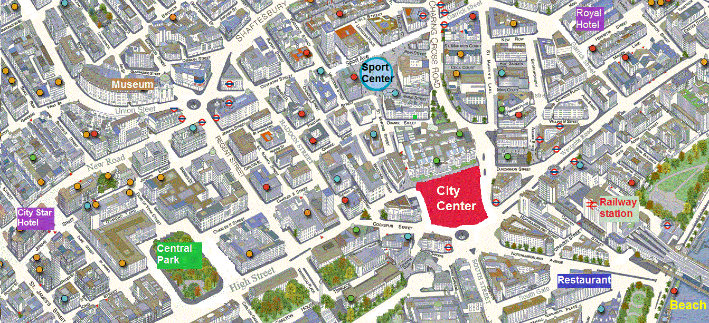

*Figure 5.13.3.4 Map used to find shortest route on the website.*

#### Underline graph

The Dijkstra algorithm works on graph rather than on map as it is display on the website. When start point and destination point selected the algorithm will find shortest route and it will calculate the distance between each nodes and print the total distance from the start point to the end point (destination) as well as total time has taken from the start point to the end point. Below is Underline graph to find shortest route using Dijkstra algorithm.

ghgg

Union St

Museum

Roundabout

Coventry St

Sport Ave

Wardour St

Sport Centre

Charing Cross Rd

Westgate Rd

Garrick St

Royal Hotel

Railway Station

5 yards

30 yards

7 yards

15 yards

10 yards

15 yards

15 yards

5 yards

5 yards

5 yards

32 yards

30 yards

31 yards

15 yards

10 yards

20 yards

20 yards

15 yards

18 yards

10 yards

7 yards

10 yards

5 yards

26 yards

15 yards

15 yards

5 yards

10 yards

5 yards

10 yards

City Star Hotel

New Rd

4 yards

Regent St

*Figure 5.13.3.5 Underline graph to find shortest route onwebsite.*

20 yards

Northumberland St

South Gate

Beach

Craven St

10 yards

22 yards

City Centre

City Centre Roundabout

Cockspur St

Haddon St

5 yards

Charles II St

5 yards

30 yards

Central Park

King St

Duke St

High St

Northumberland Ave

Restaurant

Where the name of nodes are the street, roads or avenue, I meant particular point within each of them.

Each nodes are stored in the routes table in the system`s database as well as the distance and the time taken between each nodes by walk and by drive are also stored. (Distance and time taken between nodes are imaginary numbers only).

From the above graph the shortest route from City star hotel to Museum, the distance between them and the time taken by walk and by drive will be as follow:

|  |  |  |  |
| --- | --- | --- | --- |
| Shortest route from City star hotel to Museum | Distance | Time taken(walk) | Time taken(drive) |
| City start hotel to Duke St  Duke St to New Road  New Road to Roundabout  Roundabout to Union St  Union St to City Museum | 7 yards  4 yards  30 yards  10 yards  5 yards | 00:04:00  00:02:00  00:15:00  00:05:00  00:02:00 | 00:02:00  00:01:00  00:07:00  00:02:00  00:01:00 |
| City star hotel 🡪 Duke St🡪New Road🡪Roundabout🡪Union St🡪Museum | **55 yards** | **00:28:00 mins** | **00:13:00 mins** |

*Table 5.13.3.5Shortest route between City star hotel to Museum.*

# Testing

## Web standard validation

There is possibility to make mistakes whilst writing HTML or CSS codes, and sometimes it looks fine on the web browser but might actually contain some important errors. Therefore it is imperative to validate the code and check if it is picking up any errors.

W3C (World Wide Web Consortium) mark-up validator is a software program that can check HTML and CSS documents against web standards.

### HTML validation

Figure 6.1.1 showed that the system to be validated as HTML.

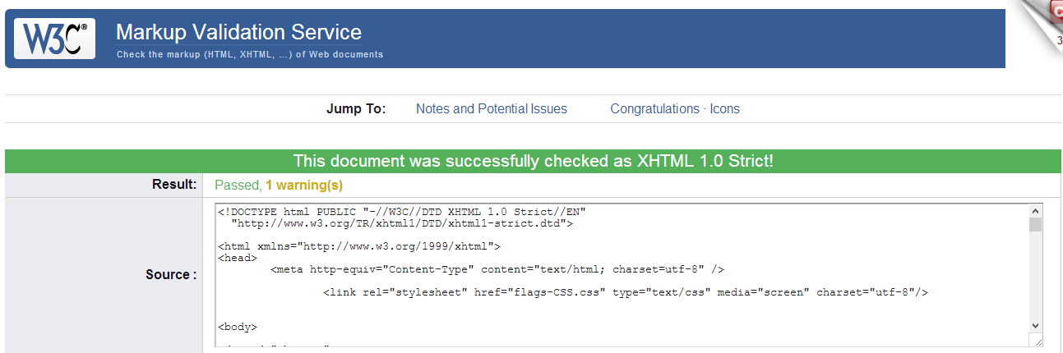

*Figure 6.1.1 Mark-up validation test.*

### CSS validation

Figure 6.1.2 showed that the system to be validated as CSS.

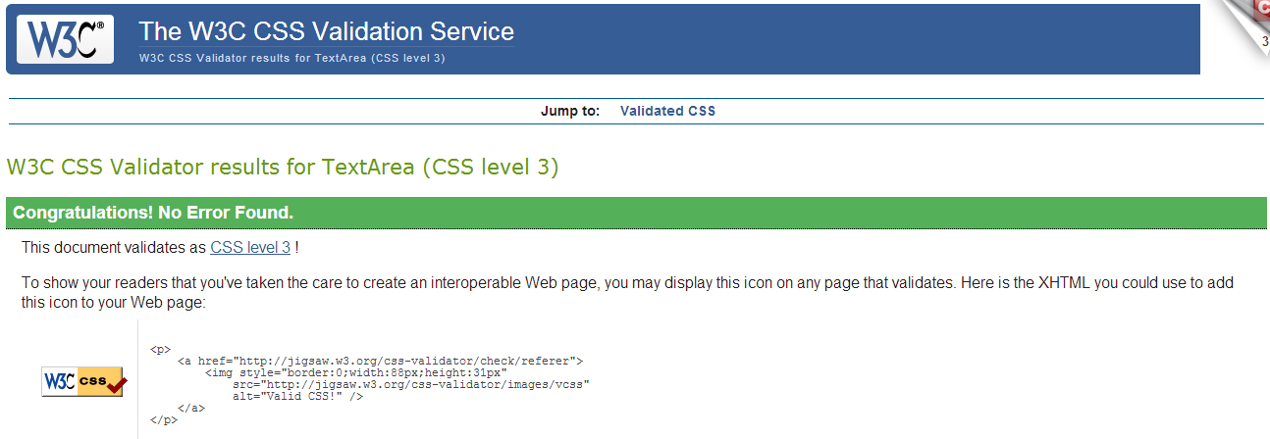

*Figure 6.1.2 CSS validation test.*

## Web browser compatibility

Users are using various web browsers to view websites, each browser having a different interpretation of website codes in a slightly different manner. This means it is possible that a website may appear for different searches by using different browsers, and therefore it is important to test the system in the majority of web browsers to ensure it behaves in the way it is expected to.

### Firefox

Figure 6.2.1 shows Index page in Firefox.

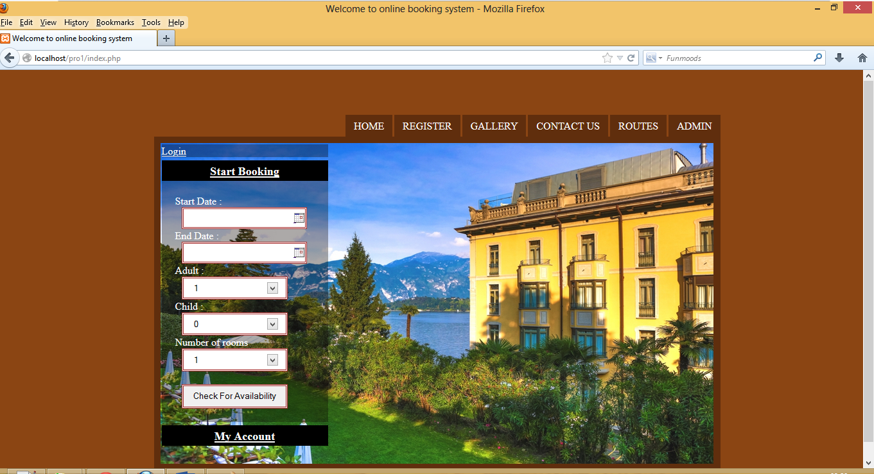

*Figure 6.2.1 Home page in Firefox.*

### Google Chrome

Figure 6.2.2 shows Index page in google chrome 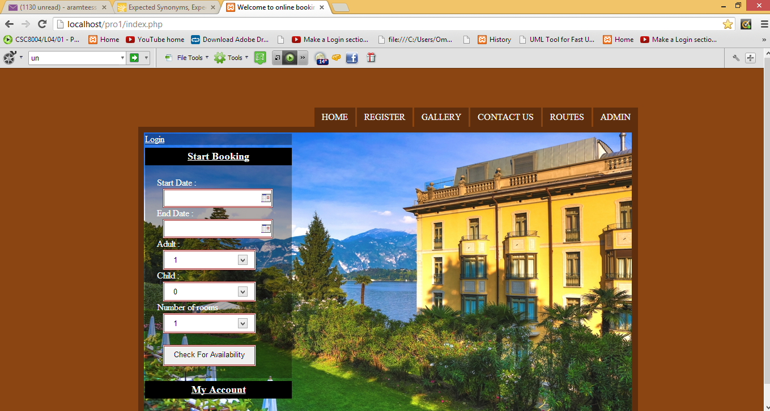

*Figure 6.2.1 Home page in google chrome.*

### Internet Explorer

Figure 6.2.3 shows Index page in Internet Explorer (IE9).

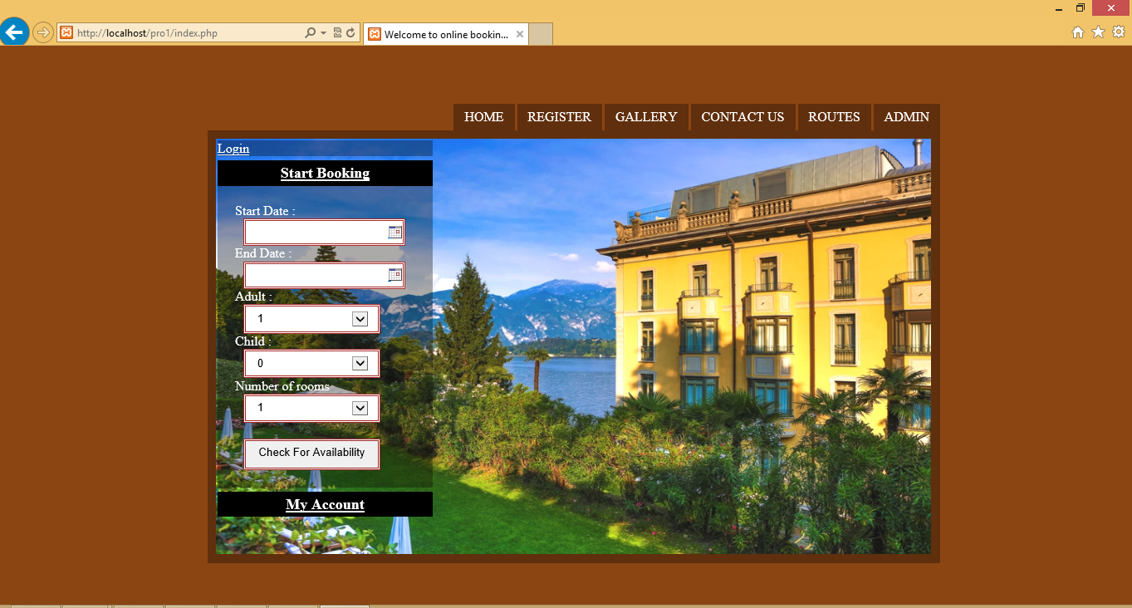

*Figure 6.2.3 Home page in internet explorer (IE9).*

### System testing

#### Home page

The Home page is the first encounter of any booking process where the user can choose check-in and check-out dates, number of adults and children, and the number of rooms. If the user selects the same date for check-in and check-out then a message *“Cannot have same start and end date”* will pop-up and the user has to restart again.

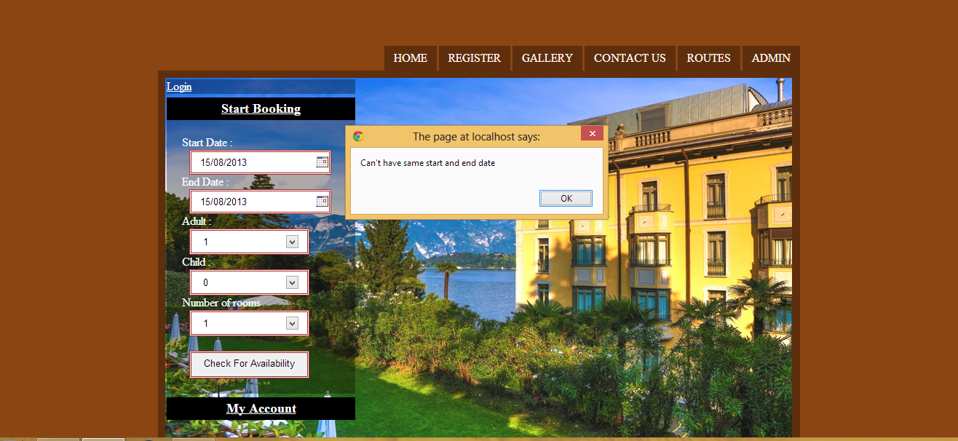

*Figure 6.2.4.1 same check-in and check-out date entered in home page.*

#### SelectRooms page

SelectRooms page will a display list of available rooms according to the user`s demand (check-in date, check-out date, number of adults, number of child and number of rooms).

If the room has already been booked by another user then it will show as “unavailable” in the availability rooms listing.

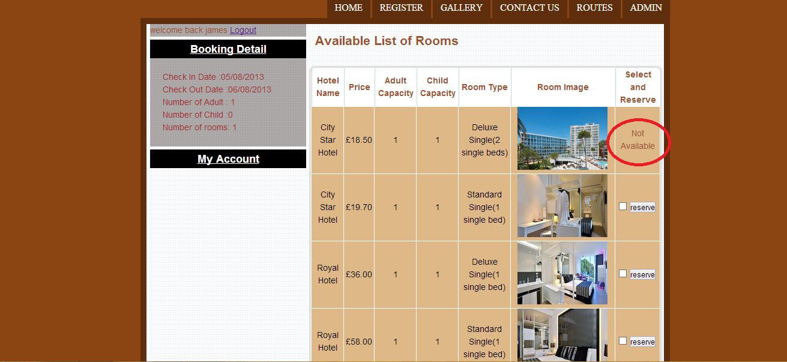

*Figure 6.2.4.2 list of available rooms with non-available room.*

#### Register page

The user must register in order to create an account and login in to the system to complete the booking process. It is important that the user inputs a valid email address and does not miss any required field from the registration form. If the email address is invalid, a message “Invalid email” is generated [see figure 6.2.4.3(a) below] and if any field were missing, a message “Required field” will pop up [see figure 6.2.4.3(b) below].

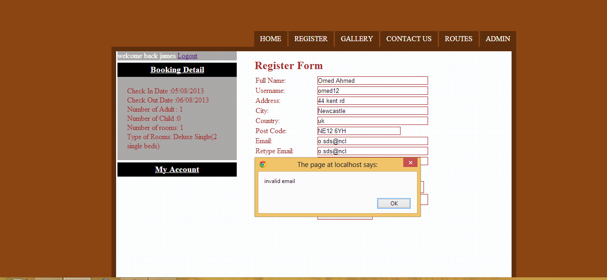

*Figure 6.2.4.3(a) invalid email in register form.*

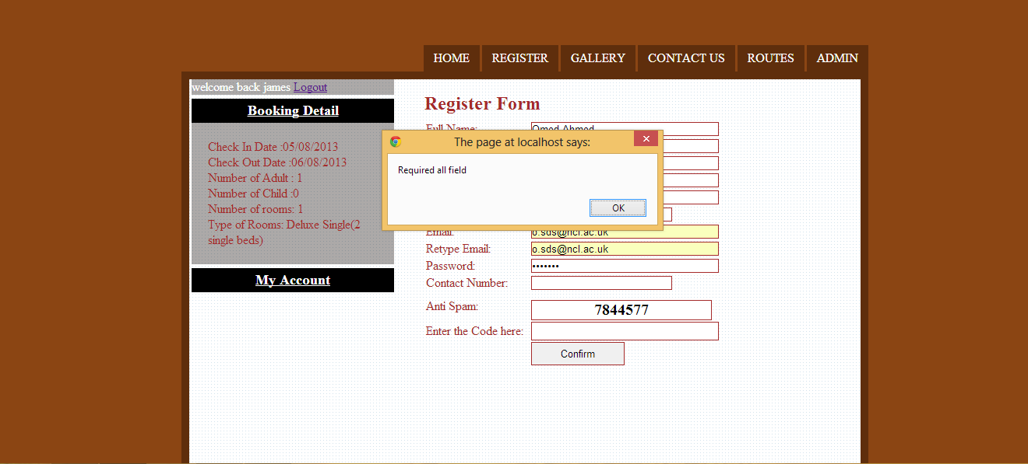

*Figure 6.2.4.3(b) missing fields in register form.*

#### Routes page

The Routes page is the webpage where user can find the shortest route from hotels to tourist attraction sites or vice versa. It also allows the user to avoid or go via some particular routes.

If the user selects the same place from start to destination or he/she selects the same place to avoid and to go via, then the system will give an error message stating “wrong choice, please try again”.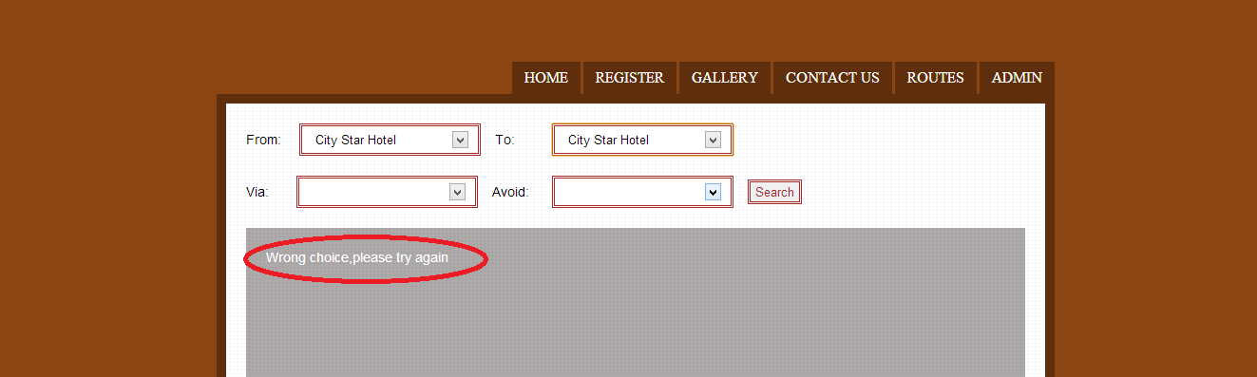

*Figure 6.2.4.4 Select wrong choice.*

# Evaluation

In this chapter, the system will be evaluated against the requirements which have been gathered in the requirement analysis chapter. An attempt will be made to explain whether the system has met all of the requirements, as well as critically apply the usability heuristics to the system.

## Requirements

### Make reservation in advance

The system allows the users to book a room in advance by selecting the date in the check-in and check-out fields. These fields will allow the users to select from current and future dates, and so, past dates will be unavailable for users to choose from in the check-in and check-out fields.

**Current Date**

**Past Dates**

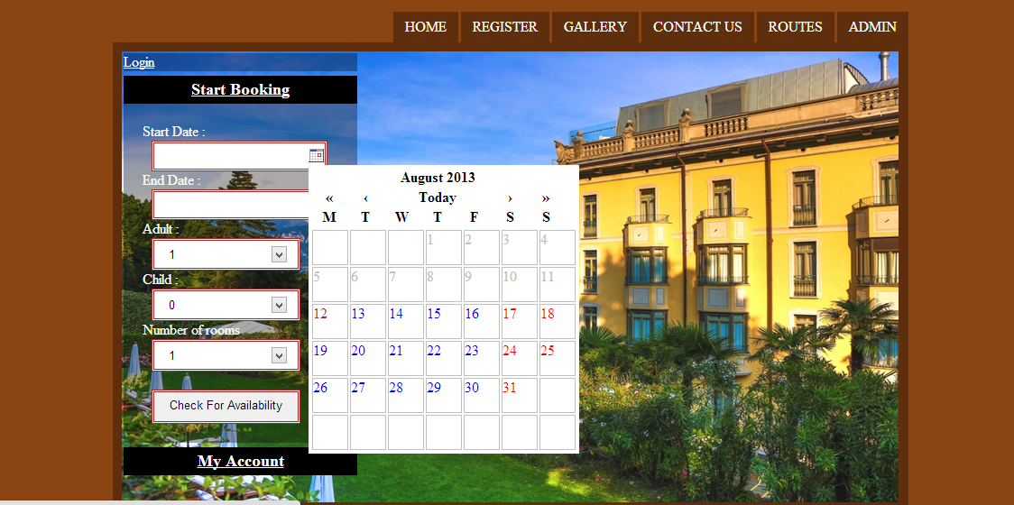

*Figure 7.1.1 Make reservation in advance.*

### Create an account before make reservation

The user has to create an account in order to complete the reservation process. The main advantage of creating an account is that the user can log in to his/her account and mange personal details such as modifying mailing address or contact number, as well as to view, cancel or print a reservation.

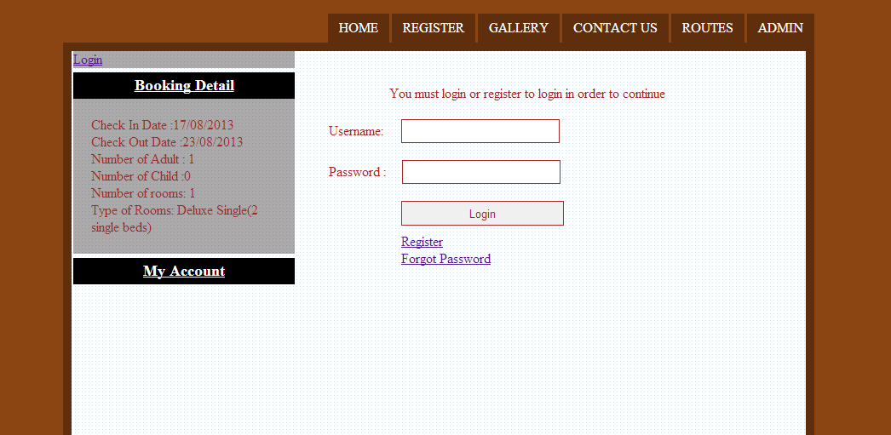

*Figure 7.1.2 Create an account before make reservation.*

### User cancel reservation

When a user has successfully created an account and completed the reservation process, he/she can log in and delete a reservation in the MyAccount area.

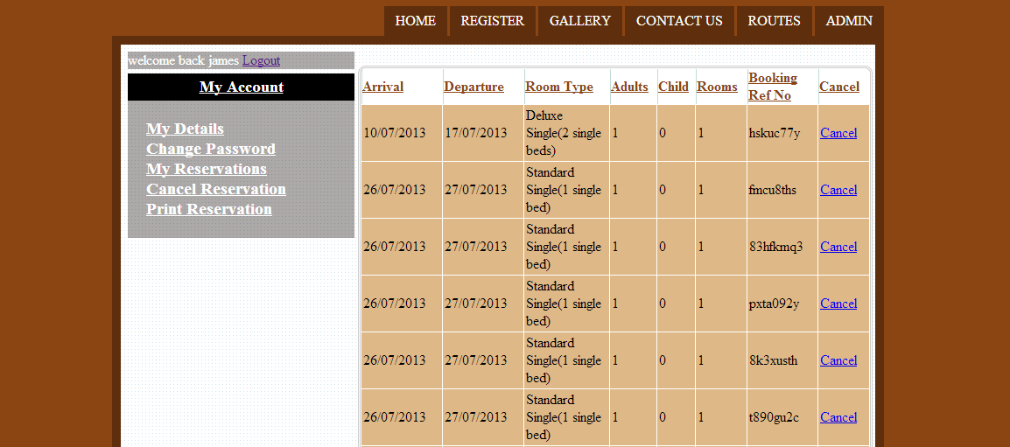

*Figure 7.1.3 User cancel reservation.*

### User view reservation

When the user has successfully created an account and completed the reservation process then the user can log in and view his/ her reservation in the MyAccount area.

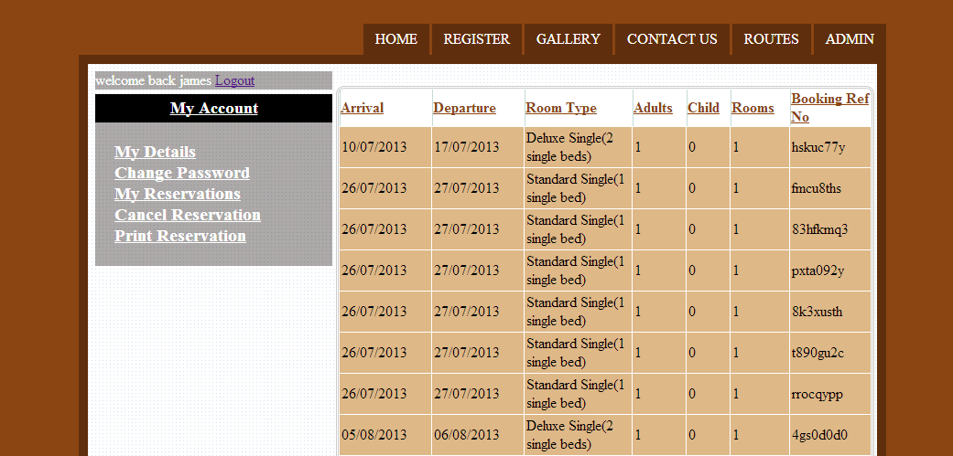

*Figure 7.1.4 User view reservation.*

### Modify user personal detail

When user has successfully created an account and completed the reservation process then user can login and modify personal details in MyAccount area.

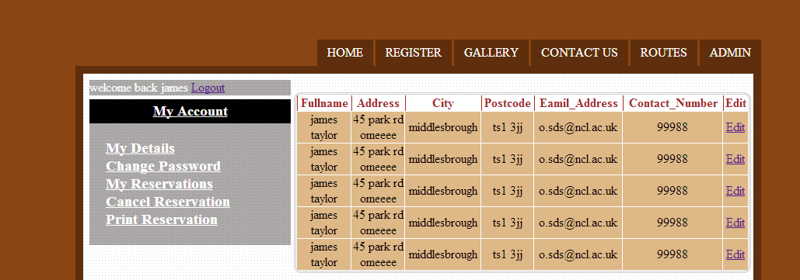

*Figure 7.1.5 Modify user personal detail.*

### Password recovery

The user is able to recover their login password if it is forgotten by first providing user’s email address. If the user’s email address is found in the system’s database, which means the user exists, a random password will be generated and sent it to user’s email address, thereafter allowing the user to change the password.

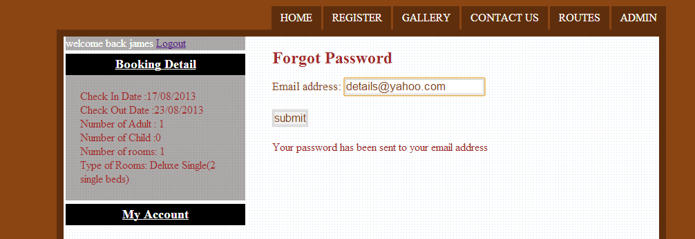

*Figure 7.1.6 Password recovery.*

### Change password

Users can change current login password to a different password at any time by logging in to their MyAccount area. The current login password has to be entered as well as the new password.

By changing the login password the user will automatically be logged out and the new password will be required to log in again.

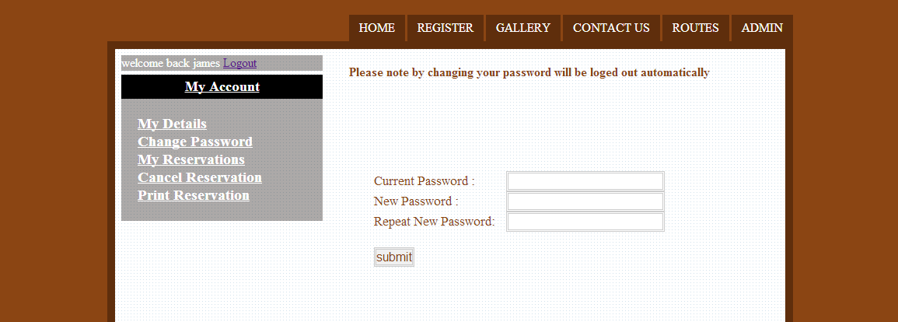

*Figure 7.1.7 Change password.*

### Receive confirmation email on every successful booking

The user will receive a confirmation email on each successful booking. The email contains the following:

* Check-in date
* Check-out date
* Number of adult
* Number of children
* Number of rooms
* Type of room
* Booking ref number

### Provide information about tourist attraction places, restaurants and etc...

This is a new feature which has been implemented into the system. Users can find tourist attraction sites and restaurants for example, in addition to finding the shortest route leading to them and the distance and time taken by walking and driving.

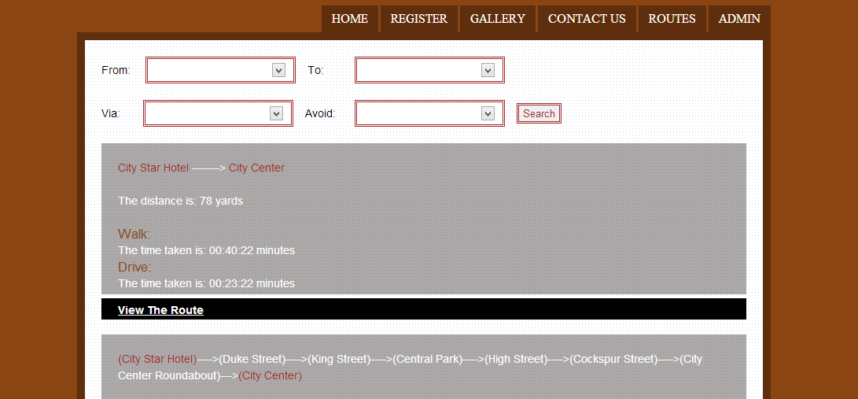

*Figure 7.1.11 Provide information about tourist attraction places and restaurants.*

### User ability to contact administrator

Users will fill out the Contact Us form on relative page in order to contact the administrator. The administrator will then be able to see all of the user’s past and present comments by logging in to admin area and replying directly to the user’s email address.

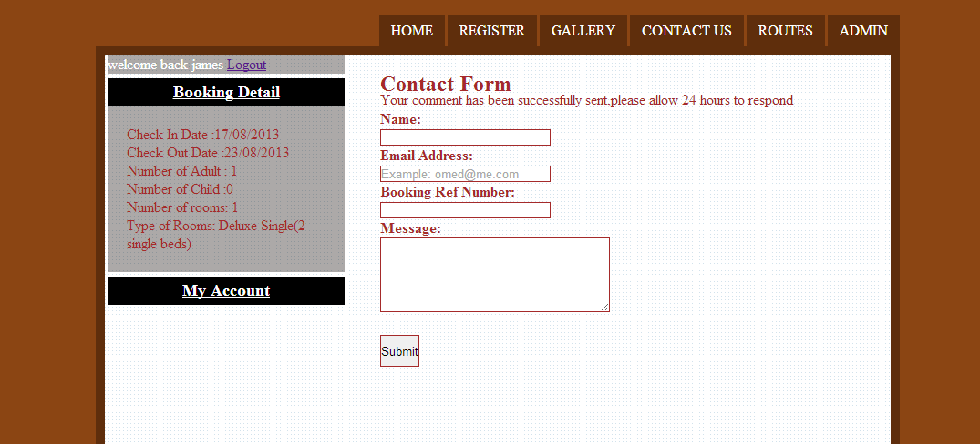

*Figure 7.1.12 Contact administrator.*

### View and delete reservations by administrator

The administrator will log in to admin area and view the list of reservations from the various users, each of which can be deleted at any time. Once the administrator deletes the reservation, it will be deleted in the system’s database as well. This means that the reservation will be delete completely from the system.

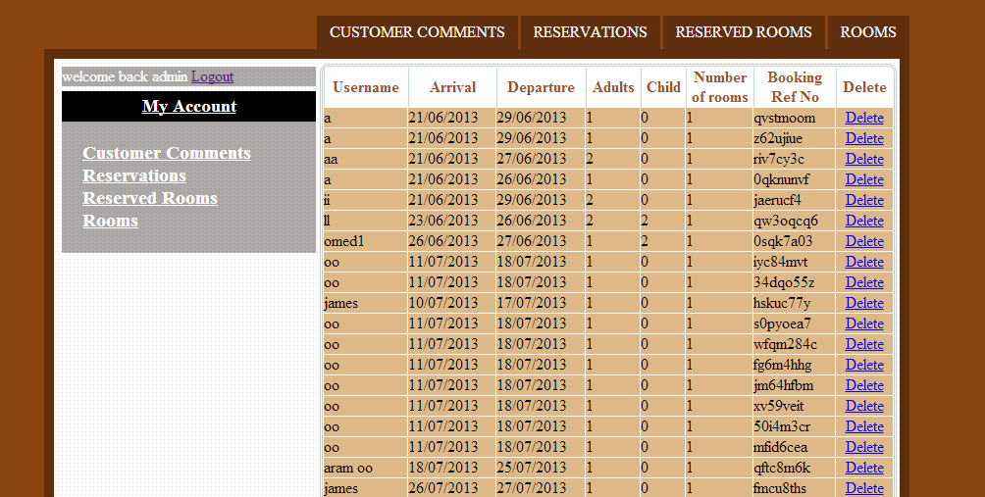

*Figure 7.1.13 View and delete reservation by administrator.*

### View, edit and delete rooms by administrator

The administrator can login in to the admin area and view, edit and delete rooms. By editing rooms the administrator is able to change the type of rooms, the room’s description, hotel’s name, and images of rooms and so on, or even delete the room entirely from the system at any time.

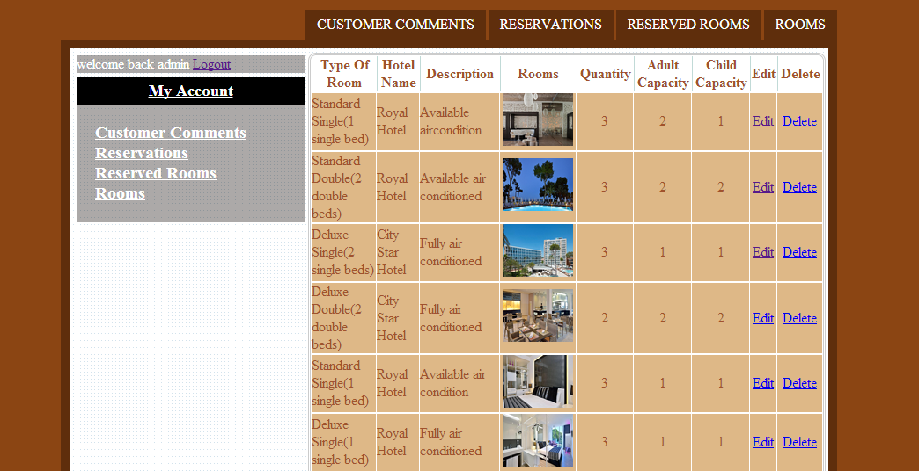

*Figure 7.1.14 View, edit and delete rooms by administrator.*

### Read and delete user comments by administrator

The administrator can log in to the admin area and read comments by users and delete them at a time.

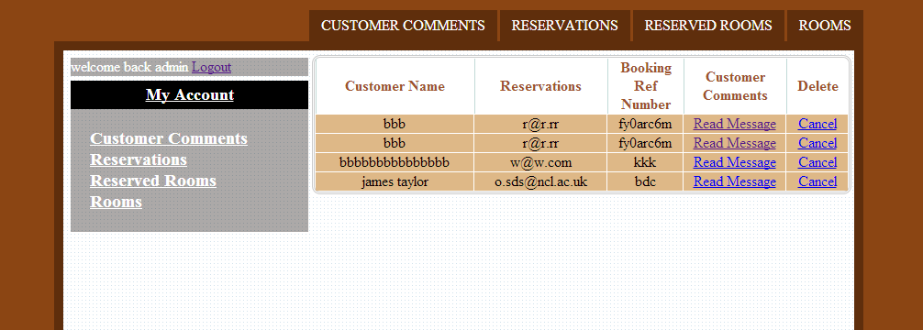

*Figure 7.1.15 Read and delete user comments by administrator.*

### User print reservation detail

Successfully completed reservations can be printed by the user when he/she has logged in to the MyAccount area.

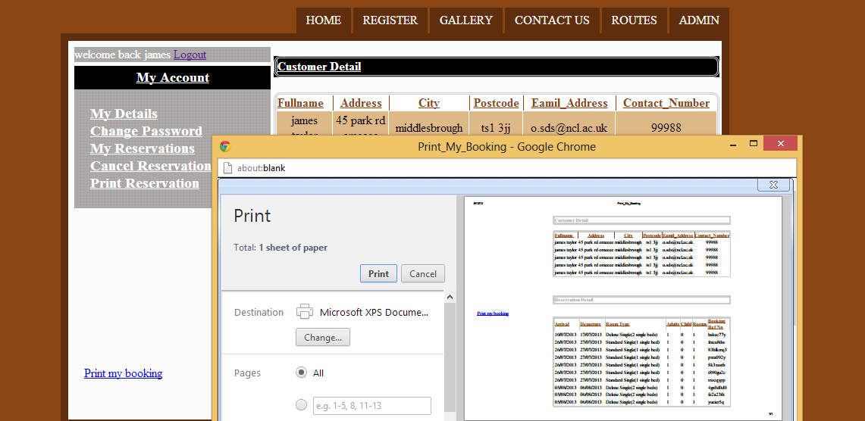

*Figure 7.1.16 User print reservation detail.*

### Usability

Usability means how the system is useable to its users and how easy it is for them to find what they want, for example, simple GUIs and user-friendly attributes. Usability heuristics will be applied on the system in more details in section 7.2.

### Performance

Performance means how the system reacts to user’s input or how fast the system responds. There are some steps which should be taken in order to make the system as fast possible:

* Put all of the images in one separate file since this will reduce the amount of resources that are required to host it.
* Use one separate file to put all of the cascading style sheet (CSS) codes in order to reduce duplication of codes.
* Use one separate file to put all of the Java script codes in order to reduce duplicate codes.
* Use W3C (World Wide Web Consortium) mark-up validator to check HTML and CSS documents against the web standards.

### Reliability

Reliability means ability of the system to perform multiple functions. Some important steps have been considered when the system has been developed to make sure the system comply with reliability standards.

* Identify number of bugs
* The system will produce a correct out put
* The system doesn’t wear out
* After bad result the system can continue to operate

### Maintainability

Maintainability means easy to fix the system when brake down occurred and also easy to increase performance, improve usability and make it easier for others to maintain it.

Considered steps to make the system maintainable:

* The system code is readable and easy to understand
* Refactor code which help to improve readability
* Documentation which is relevant to helps other to understand the system

### Availability

The system is available to everyone at all time and from everywhere around the world. To test whether the system is available or not, uptime and downtime must be analyse as well as the server from different cities and countries around the world.

Steps has taken to check the availability of the system:

* Visit the system from different servers
* Visit the system by some friends in different cities and countries
* Check the system whether down or not in different times of a day

### Accessibility

Accessibility means the system is accessible to users who are handicapped in some way such as colour blind or poor eye sight.

To make the system accessible, two steps has been considered:

* Use clear and large font as well as suitable background colour
* Subtitle text to every images which help the poor eye sight or colour blind users to understand the meaning of the image

### Security

Security is a very important issue and has to be considered very seriously. The main security issues of booking systems are secure payment methods and secure login system.

#### Payment methods

Because there is not payment process in the system therefore secure payment methods has not been implemented.

#### Login system

Login is a procedure to get access to a system or application. Usually login requites user name and password, username is visible when entered at a keyboard but password must be displayed as dot and kept secret. User has to register as a member to create login user name and password.

When user register to create a user name and password, the password will be stored in a system’s database as a random numbers and letters so if someone access to the database or even the administrator will not be able to see the password. The process of hiding the password call password encryption.

Figure 7.1.23.2 shows the encryption of customer’s password and displayed as random characters.



*Figure 7.1.23.2 Password encryption.*

## Apply usability heuristics

### Visibility

Online booking clearly informs the user what is going on through suitable feedback within tolerable time. For example:

* Inform user when registration process was successful
* Inform user when login process was successful and print out user’s name on the top of each pages.
* Inform user when booking process was successful
* Inform user when forgotten password has been send to user’s email address
* Inform user when contact us form has been successfully submitted to administrator

### Match between the system and real world

The website scores very good on this heuristic, Home page gives a clear idea to its users that it is a hotel booking system for example there is an image of hotels or rooms rather than having a plenty texts to confuse the users and very clear side bar on left had side to search for available rooms.

### User control and freedom

The website scores quite well on this heuristic by providing very clear navigation on top of each pages to help users navigate throughout the website as well as login or logout buttons on the top left hand side of each pages.

### Consistency and standards

There is no need to spend time on the system in order to learn how to use it. There are some certain functions are behaving in the same way of the other booking systems such as:

* Search for available rooms
* Register form
* Login and loge out form
* Contact us form
* Make reservation
* Cancel reservation
* Forget and change login password

### Error prevention

Error prevention has clearly been implemented to the system, for example:

* Check if user select the same day for both check-in and check-out dates
* Check whether all required field has been provided before submit the register form
* Check whether user’s email address is valid before submit the register form
* User has to re-enter the email address and they both have to match each other before submit the register form
* Check whether all required field has been provided before submit the contact us form
* Check if user select the same place for both from(start) and to(destination) in the drop down list in routes page to find tourist attraction places
* Check start and destination does not match the avoid and via in the select drop down list in routes page

### Recognition rather than recall

The system scores quite well on this heuristics. For example when user enter an email address and it was invalid, in this case valid email address has to entered rather than repeat the whole process from the beginning.

### Aesthetic and minimalist design

Attractive and beautiful design and in the other hand it is very simple to use makes the system scores fairy well on Aesthetic and minimalist design. Such as:

* Match the background colour with navigation bar colour
* Math the background colour with content colour
* Match the content colour with font colour

### Help users recognise and recover from errors

The website scores very well on helping users to recognise and recover errors. For example if user enter a wrong password in login form then the popup message will appear to let the user that the password entered was wrong. This is helps the user what was wrong and to how correct it rather than return the user to login page.

### Help and Documentation

The system scores very well on this heuristic because of the following reasons:

* Login form, register form, booing form and contact from are clearly labelled
* Clear map with all destination places and roads, streets and etc… between them to find tourist attraction places
* Provide an image for each rooms with description for each them.

# Conclusion

Hotel is one of the most flourishing industries in the world. An increase in the tourism supports the tourism industry, which is based on the hotels for their accommodation purposes. However, it has been identified that the online booking system is of utmost importance for the hotel industry. By doing the bookings online, an individual can easily book the accommodation from remote location. It has been identified that besides the process of booking, there are other factors too, which play a major role for the tourists.

An individual, who searches for the hotel, does not want to book by just reviewing one hotel only. Instead, the person looks to browse through different range of hotels available for him. Keeping in mind this aspect, the website has been designed to allow an individual for searching all the available hotels for him and then choosing the one which suits most as per the need. An individual can easily browse to find the cheapest hotel for him. This is quite important aspect for someone who has a tight budget. Besides this, there may also be the possibility that even after booking the hotel, an individual may need to cancel or modify booking. So, these features are also covered in the website in order to allow the customers to book online through this website.

## Meeting Objectives

There were several objectives to be achieved through this report. Each of the objectives are mentioned in chapter one. Below were the objectives of the success/ failure of achieving each of these:-

* This project aims to develop an online booking system for hotels.

This objective has been thorough achieved as an online booking system for hotel has been developed. In order to achieve this, firstly the theoretical study was conducted to understand about the hotel industry, and selecting the programming language that is most suitable for programming a web based application to fulfil the requirements. So, this was an interesting part of the study, where I had worked in a satisfactory manner.

* Users are able to search for the cheapest hotels.

The users have an option to check the list of available rooms, and compare the cost of accommodation in each of these hotels so as to select the cheapest option that is suitable for them. This objective has also been achieved in the development work, which shows a great sign of efforts put in programming section of the report.

* Account area is provided where users are capable to have their own profile so that they can change/ cancel booking or modify their details. In addition, once a purchase was made or a customer left the hotel, the system will automatically update the availability of services without human interaction.

The above objective has been achieved as well, which represents the required degree of efforts have been put in the programming section of this report. So, I had worked quite well in completion of this report to an acceptable standard.

* Admin area is provided where the administrator can view users booking details and add/edit or delete rooms or hotel.

This has been designed as a separate section for the administrator, which is mainly responsible for controlling the information related to the hotels and rooms. The hotel/room information can be manipulated by the admin department, who can also view the list of users who had booked the rooms. The admin can even manage the comments by accepting or deleting the comments put by the users.

* Tourist attraction places and restaurants and fastest routes leading to them, distance and time taken can be found through the system by using Dijkstra algorithm.

The tourists are allowed through the website to view the major tourist attraction places, and even find the shortest distance and time taken to reach to these places by walking/ driving towards the destination.

## Positive and negative aspects

At the start of the project, the only programming language that I have been introduced to was Java programing. So it was really difficult to build a website using deferent programing languages such as (PHP, Java script, HTML, XHTML, CSS and MySQL). Therefor I have spent a lot of time on research and learn myself on each programing language to implement it on my system. At the beginning I was really struggled to understand PHP language as it is the main programing language to build the website, I also had very short time period to do this project and because it was my first individual project and having no skill to plan hence I was really struggled to manage my times as I was not sure that the time will allow me to complete everything at the right time. So at the beginning I have decided to do all of the programming part and then move on to writing up.

Fortunately by managing my times, choose what is priority, being my own monitor, devoting appropriate time for each tasks and my deep research helped me to get better day after day until I have managed to implement all the function I was planned at the beginning as well as writing the report in right and efficient time.

With regard to the technologies used in this project, PHP was used as an open source scripting language for designing the product as per the specified needs with MySQL as the database, which helped in provision of enough capability of the website to maintain the record of target customers. Not only the functional requirements, but the non-functional requirements are also covered in this project. This is highly beneficial for producing the web based application that is useful for the end customers in a real life. One should not find any trouble in using the website; else the people may avoid using such application. So, the usability testing has been conducted in an appropriate manner, with high priority.

Testing was conducted to identify whether the website is compatible with different types of well renowned browsers such as Google Chrome, Firefox, and Internet Explorer. As it was found that the website is compatible with each of these, the programmer felt quite how the web application would work in real life, if implemented in any hotel. Based on the data entered, the outputs were generated to know the reporting system followed in the web application confident in proceeding further towards system testing. The fake data was entered to know.

Beside this evaluation was also conducted firstly to make sure all of the initial requirement were met. Secondly apply usability heuristics on the website and identify usability problems against each heuristics.

Overall, it can be concluded that a highly useful web based application has been designed for usage in the hotel industry. The wide ranges of facilities are provided in the application, which can be useful in the real life situation for the travellers who search and book their rooms in the

## Reflective Learning

This dissertation had been of great help for me in understanding the actual manner in which the programming has to be carried out. It is quite a complex task to understand the actual requirements of an industry, and then implement the solution for them. However, by working patiently, I was able to understand the manner in which a customer usually searches for the hotel for their stay, and books the room online. To understand this, I had explored several similar types of websites, which gave me an actual experience of working in the field of programming, so as to analyse the requirements as the part of System Analysis and Design. Following this, I had worked a lot on programming and design a database, so as to programme a solution that could be of great usage for the hotels. The users can easily book the hotel by searching from the list of available hotels on the website.

Besides this, I have also learnt the theory attached with the subject. It is always interesting to explore the different phases of theory for having a sound awareness over the programming language one is working on. By combined usage of the theoretical knowledge, and practical experience of working in the programming section, it became possible for me to formulate a solution that could be of great help to the hotel industry. Also, it can be a great source of revenue for the programmer.

## Scope of future research

It has been suggested that next study can make use of the work carried out in this dissertation as the base for further study. Enough theoretical work has been carried out in this report, which can be further explored by stressing on the programming part. As the prototype has also been developed in this dissertation work, it seems a great degree of efforts put by the writer to reach towards the aims and objectives of the report.

However, there is still the scope of further improvement. The next studies can focus on enhancing the web based application to make it live on the World Wide Web and accept online payment, in this case user needs to though payment process before complete booking process.

Also in next studies, the programmer can work towards adding the Loyalty program. Under this loyalty program, the users would be able to get discount for continuously booking the rooms through this website. This would help in attracting more and more customers for this website. Also, more rigorous process would be used for the testing purpose, prior to making it live on the web. To test the usability of this web based application, potential customers would be asked to give their feedbacks on a regular basis, so as to enhance services for them.

Additionally, the integration with major social networking sites such as FaceBook, Twitter, LinkedIn, and MySpace etc. could be done to further allow the customers to share their stories, or their experience while staying in the hotels, on these sites as well. This would help in further promoting the website through the quick means of marketing, knowing as Social Media Marketing. By making the website live, it can be a great source of revenue for the long-term. The hotels would also be interested to pay and register on the website (by even paying the fees per transaction too), which has a great market presence.

# References

* Armstrong J (2004), Managing Risk: Technology and Communications, Taylor & Francis, pp.90-109.
* Belmond, W. and Sharkey, M (2006). The Easy Write:Formal writing for academic purposes. Austuralia,Pearson Education.
* Bertino, E (1999), The specification and enforcement of authorization constraints in workflow management systems, ACM Trans. Info. Syst. Security 2(1), pp.65–104.
* Bishop S. (2009), Adobe Dreamweaver CS4, Cengage Learning, pp.26-29.
* Braun, K., et al. (2002). Usability:The Site Speaks For Itself. United State of America, glasshaus.
* Brown, H., & Smith, H. (2012), Normalisation: A Reader, Routledge.
* Burgess S.(2009), Effective web presence solutions for small businesses: strategies for successful implementation, Idea Group Inc, pp.170-175.
* Clark, J (2003). Bulding Accessible Website.United State of America, illustrated.New Riders Pub.
* Coronel, C., & Rob, P. (2009), Database Systems: Design: Design, Implementation, and Management, Cengage Learning.
* Curtis, G. (2002), Business information systems: analysis, design, and practice, Financial Times/Prentice Hall, 4th edition, pp.87-98.
* Daniel, G. (2004), Software Quality Assurance, Pearson Education India,pp.45-67.
* Davies, J.(2002), Towards The Semantic Web, Willy,pp.78-91.
* De Villiers, M.R. (2010), Design and evaluation of an e-learning: a research-based approach. (Special edition), pp: 81-88.
* Doyle, S. (2000), Information and Communication Technology, Nelson Thornes.
* DuBois, P. (2013). MySql Developer`s Library, Australia Add ison_Wes.
* E.Holzschlag, M. (2002). Using HTML AND XHTML United State of America CNTB.
* Flanagan, D. (2011). Java Script.The Definitive Guide United State of America O` Reilly Media.
* Gube, J (2008). "10 way to improve your webpage." Retrieved Aug 02, 2013, from <http://sixrevisions.com/web-development/10-ways-to-improve-your-web-page-performance/>.
* James, R (2012). "Booking services." Retrieved Jun 18, 2013, from <http://www.quackit.com/web_hosting/tutorial/website_availability.cfm>.
* Margaret, R (2011). "Reliability, Availability and Serviceability (RAS)." Retrieved Aug 14, 2013, from <http://whatis.techtarget.com/definition/Reliability-Availability-and-Serviceability-RAS>.
* Neilson, J (1999). Usability Heuristics for User Interface Design. Retrieved August 02, 2013, from <http://www.nngroup.com/articles/ten-usability-heuristics/>.
* Nielsen, J. (1994). Enhancing the explanatory power of usability heuristics, United Kingdom, Academic Press Limited.
* Nielsen, J. (1994). Heuristic evaluation, United State of America,John Wiley & Sons.
* Nielsen, J. Mack, R.L. (1995).Usability Inspection Methods, United State of America, John Wiley & Sons.
* Nielsen, J., and Molich, R. (1990). Heuristic evaluation of user interfaces, United Kingdom, Academic Press Limited.
* Powers, D. (2010). PHP Solutions: Dynamic Web Design Made Easy. USA, Friends of ED.
* Prelovac, P (2013). "Explanation Usability Heuristics." Retrieved July 22, 2013, from <http://www.whatwasithinking.co.uk/2009/02/27/explaining-usability-heuristics-a-quick-guide/#.UhFxgpJJ5Hl>.
* Rahimi, S. K., & Haug, F. S. (2010), Distributed Database Management Systems: A Practical Approach, John Wiley & Sons.
* Rajlich, V (2012). Software Engineering The Current Practice.USA, CRP Press,Taylor and Francis Group,lnc.
* Rech, J., & Bunse, C. (2009), Model-Driven Software Development: Integrating Quality Assurance, IGI Global Snippet.
* Ritchie, C. (2002), Relational Database Principles, Cengage Learning EMEA.
* Ritchie, C. (2008), Database Principles and Design, Cengage Learning EMEA.
* Rob, P., & Coronel, C. (2009), Database Systems: Design, Implementation, and Management, Cengage Learning.
* Rubin, J. and D. Chisnell (2008). Handbook of Usability Testing. Canada, Wlly Publishing,lnc.
* Saltin, J. and S. Rush (2003). Making your website more usable to everyone .USA, Pearson Education,lnc.
* Schmit, C. (2010). Quick Solutions to Common CSS Problems. United State of America O` Reilly Media.
* Sharpling, G (2012). Writing a conclusion." Retrieved Aug 16, 2013, from <http://www2.warwick.ac.uk/fac/soc/al/learning_english/leap/writing/conclusions/>.
* Snyder, J. (2008). "Insight on Corporate Travel." Retrieved June 24, 2013, from <http://www.bcdtravel.co.uk/global/show_document.asp?id=aaaaaaaaaabiicg>.
* Somerville ,I (2007). Software Engineering .England, Pearson Education Limited.
* Souder, S (2007). High Performance Websites.United State of America, O` Relly Media.
* Sumathi, S., & Esakkirajan, S. (2007), Fundamentals of Relational Database Management Systems, Springer, 47(1), pp. 403-412.
* Tiwana, A (1999). Website Security. United State of America,Degital Press An imprint Butterworth-heinemann.
* Wardel, D (2012). Hotel Technology and Reservation System. United State of America,Technical Reality OU.
* Watteville, A. D., & Gilbert, L. (2000), Advanced Information and Communication Technology, Heinemann.